**Project Report on**

**Garage Management System**

The Garage Management System is a valuable tool for automotive repair facilities, helping them deliver top-notch service, increase operational efficiency, and build lasting customer relationships. With its user-friendly interface and powerful features, GMS empowers garages to thrive in a competitive market while ensuring a seamless and satisfying experience for both customers and staff.

**Milestone-01:**Create Salesforce Org

Go to **developers.salesforce.com/Signup**

Click on sign up.

On the sign-up form, enter the following details:

1. Frist name & Last name – G.M. POOJITHA
2. Email – [gandikotapooji04@gmail.com](mailto:gandikotapooji04@gmail.com)
3. Role: Developer
4. Company: GAYATRI DEGREE COLLEGE – TIRUPATI
5. Country: India
6. Postal code: 517501
7. Username: [gandikotapooji04@gdctirupati.com](mailto:gandikotapooji04@gdctirupati.com)

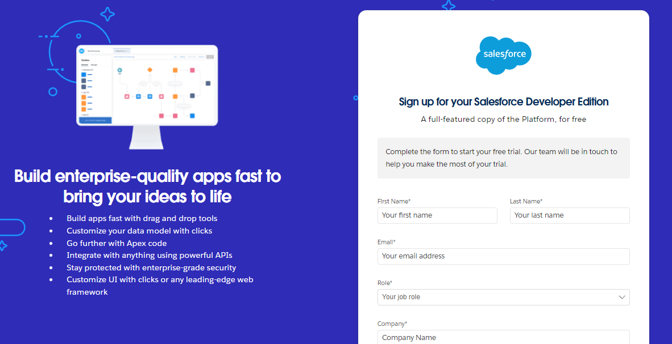

**Account Activation:**

GO to the inboxof the email that you used while signing up. Click on the verify account to activate your account. The email may take 5-10mins.

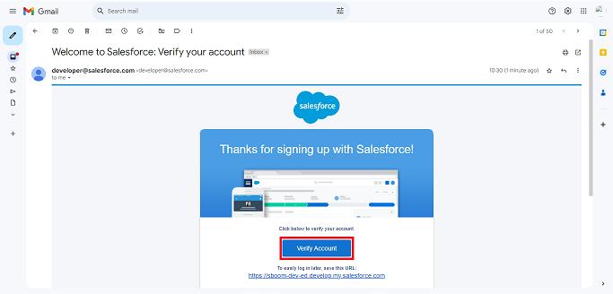

**Login to Your Salesforce Account:**

1. Go to salesforce.com and click on login.
2. Enter the username and password that you just created.
3. After login this is the home page which you will see.

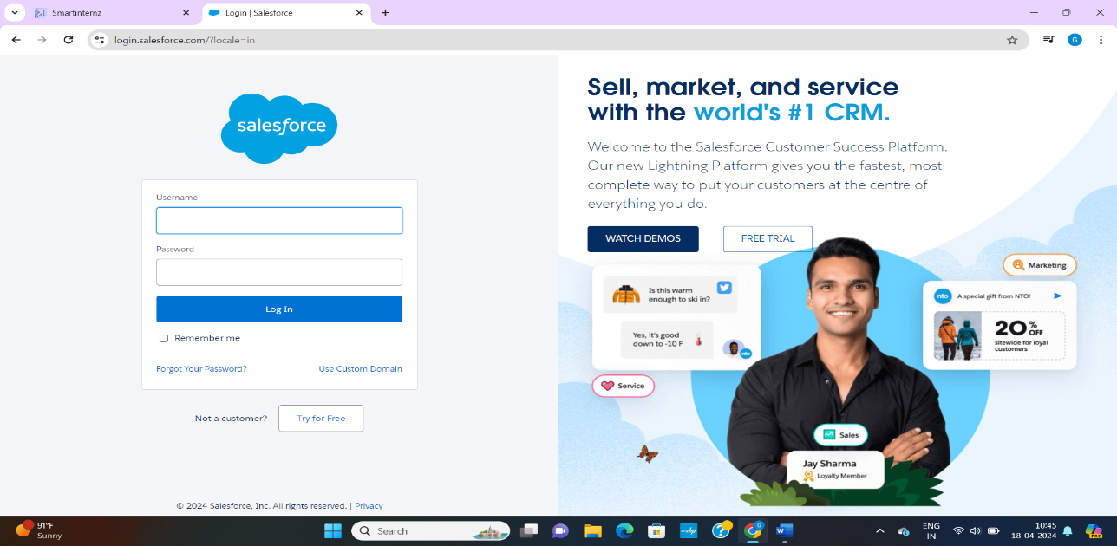e

**Milestone-02: Creation of objects**

**Object – Customer details:**

1. From the setup page >> click on object manager>> click on create>>click on custom object.
2. Enter the label name: customer details
3. Plural label name: customer details
4. Enter record name label and format
5. Record name: customer name
6. Date type: text
7. Click on allow reports and track field history.
8. Allow search
9. Click save.

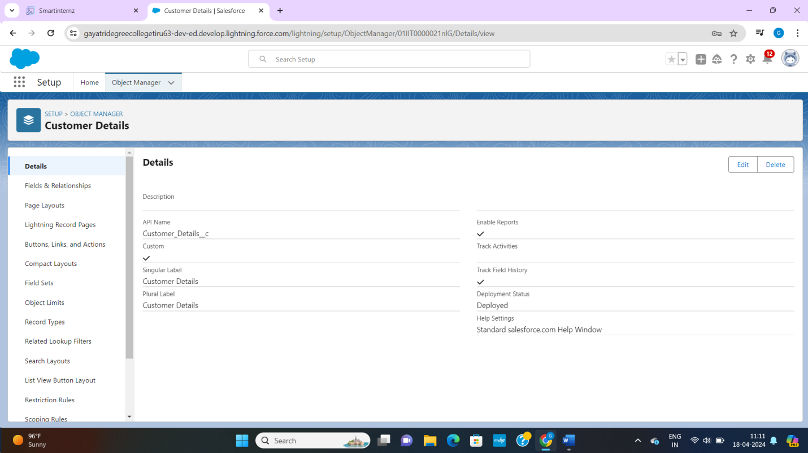

**Object – Appointment Object:**

1. From the setup page>> click on object manager>> click on create>> click on custom object.
2. Enter the label name: appointment
3. Plural label name: appointments
4. Enter record name label and format
5. Record name: appointment date
6. Data type: auto number
7. Display format: app-{000}
8. Starting number: 1
9. Click on allow reports and track field history,Allow search
10. Click save.

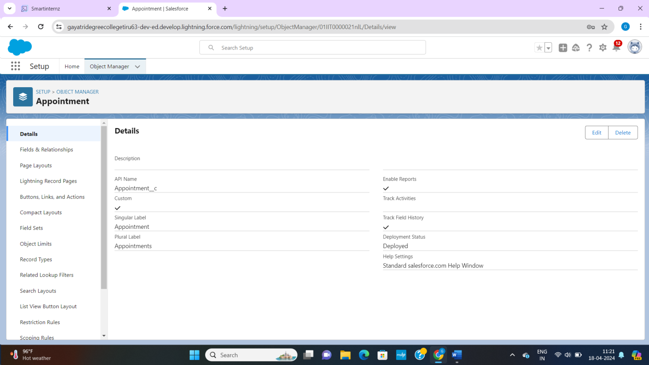

**Object - Service Record:**

1. From the setup page>> click on object manager>> click on create>> click on custom object.
2. Enter the label name: service records
3. Plural label name: service records
4. Enter record name label and format
5. Record name: service records name
6. Data type: auto number
7. Display format: ser-{000}
8. Starting number: 1
9. Click on allow reports and track field history,Allow search

10.Click save

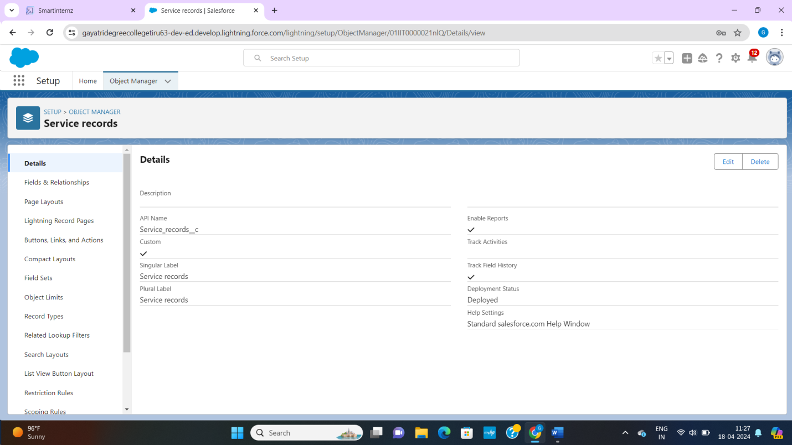

**Object – Billing Details And Feedback**

1. From the setup page>> click on object manager>> click on create>> click on custom object.
2. Enter the label name: billing details and feedback
3. Plural label name: billing details and feedback
4. Enter record name label and format
5. Record name: billing details and feedback name
6. Data type: auto number
7. Display format: bill-{000}
8. Starting number: 1
9. Click on allow reports and track field history.
10. Allow search
11. Click save.

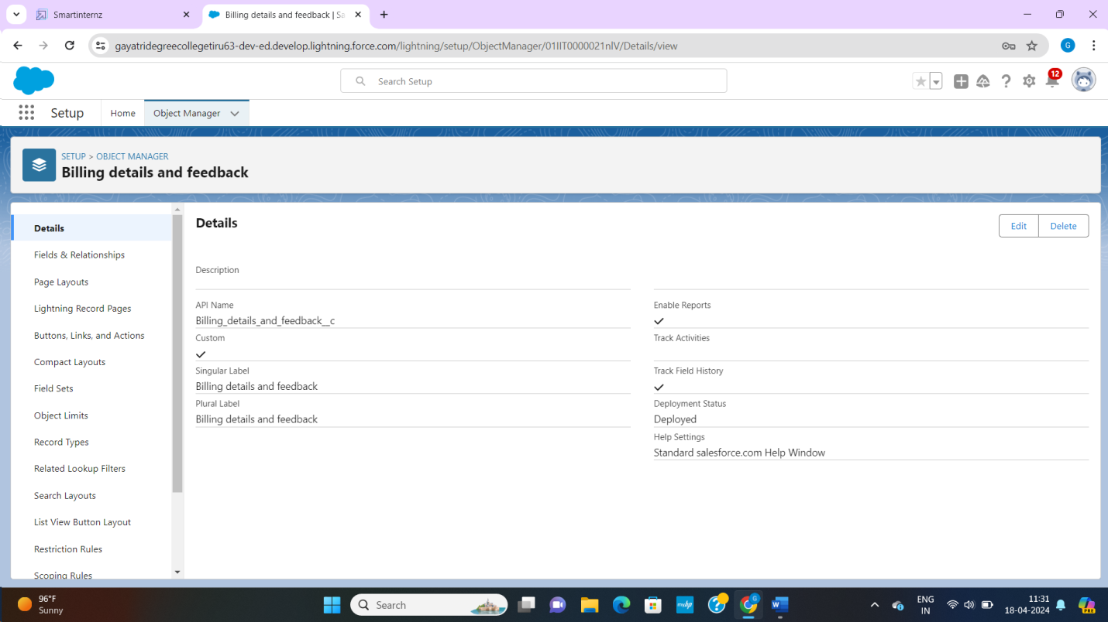

**Milestone – 03: Tabs**

Tabs in salesforce help users view the information at a glance. It displays the data of objects and other web content in the application.

Now create a custom tab. Click the home tab.

1. Go to setup page>> type tabs in quick fine bar>> click on tabs>> new(under custom object tab)
2. Select object (customer details)
3. Select the tab style
4. Next add to profiles page keep it as default
5. Next add to custom app uncheck the include tab.
6. Make sure that the append tab to users existing personal customizations is checked and save
7. In the same way create tabs for all custom objects – appointments, service records, billing detail and feedback

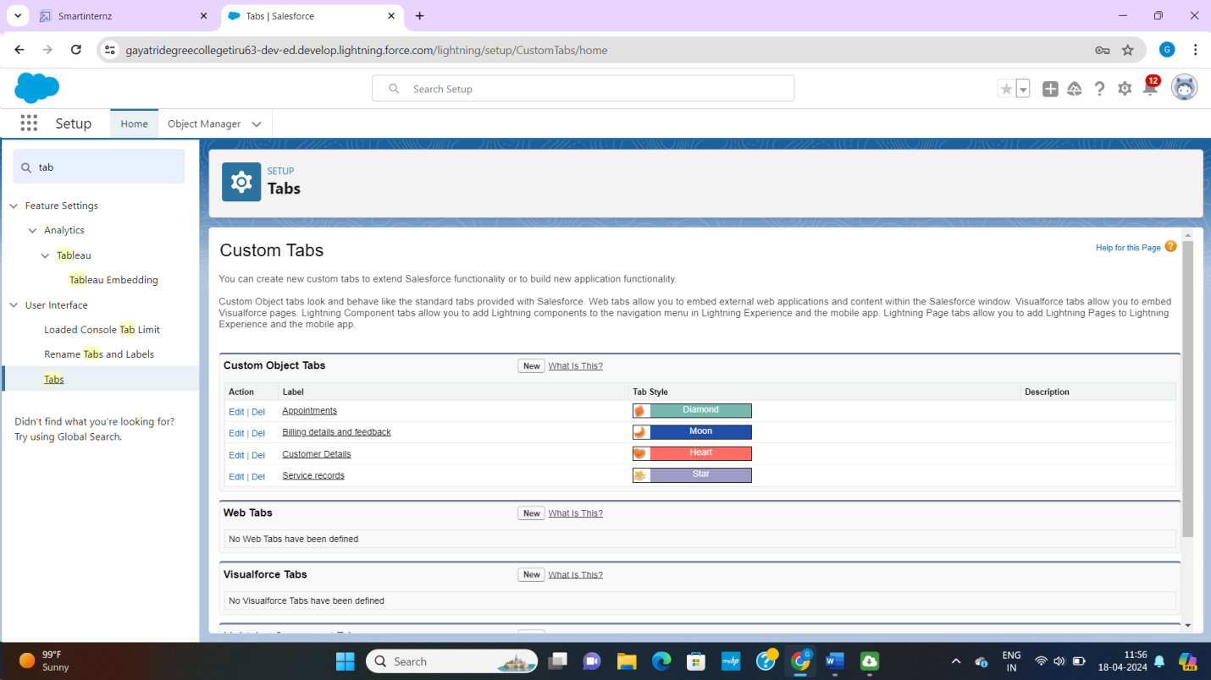

**Milestone – 04 Lightning app**

**Create the garage management application**

1. Go to setup page>> search “app manager” in quick fine >> select “app manager”>> click on new lightning app.
2. Fill the app name in app details as garage management application. Next
3. App option page keep it as default click next
4. Utility items keep it as default click next
5. To app navigation items.
6. Select the items (customer details, appointments, service records, billing details and feedback, reports and dash boards) from the search bar and move it using the arrow button. Click next
7. To add user profiles.
8. Search profile system administrator in the search bar.
9. Click on arrow button and Click save and finish.

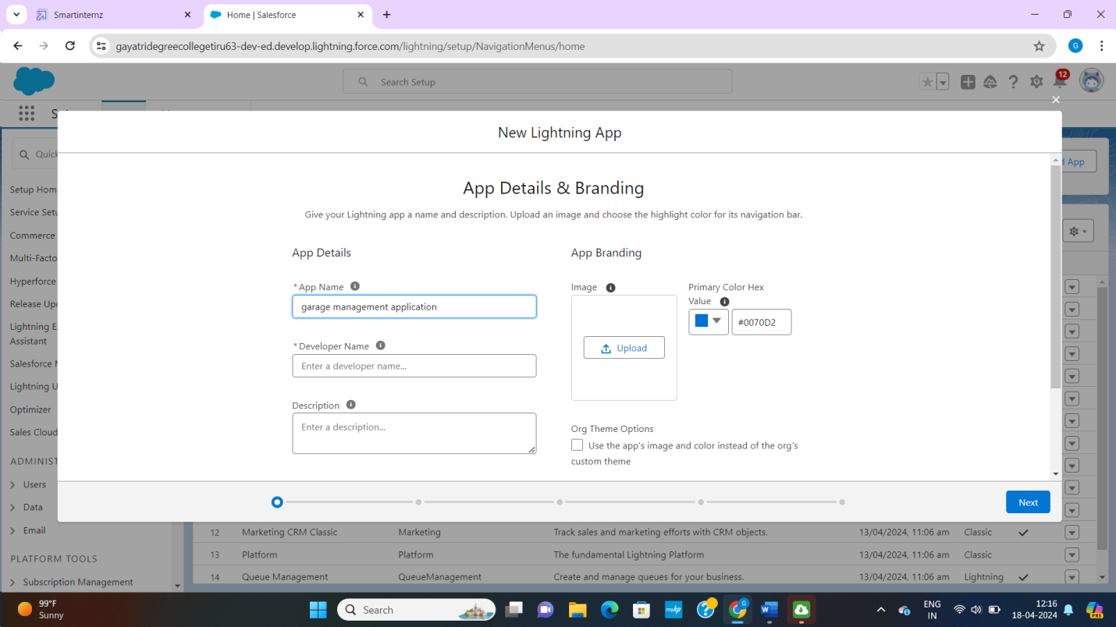

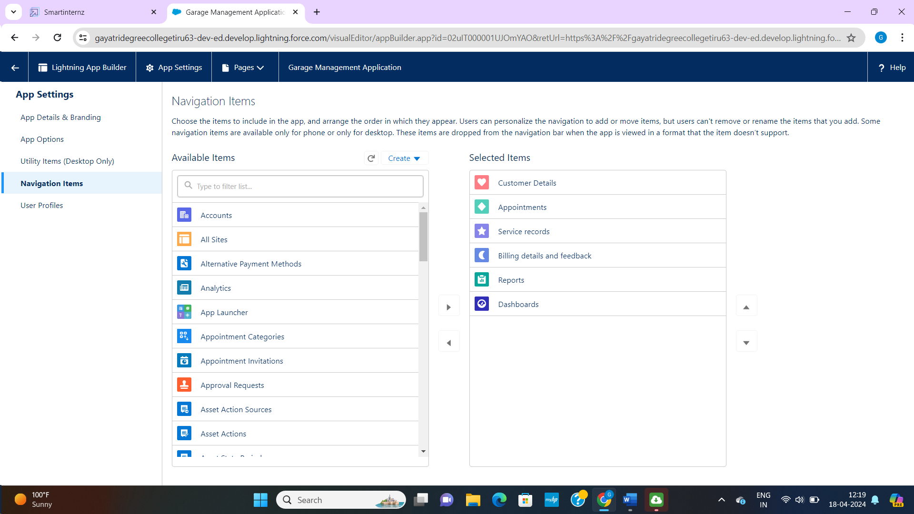

**Milestone – 05 Fields And Relationship**

**Creation of fields for the customer details object**

1. Go to setup>> click on object manager>> type object name(customer details) in search bar>> click on the object
2. Now click on “fields and relationship”, new
3. Select data type as a “phone”
4. Click next.
5. Field label: phone number
6. Field name: get auto generated
7. Click next, next, save and new

**Note :** follow the above steps for the remaining fields for the same object.

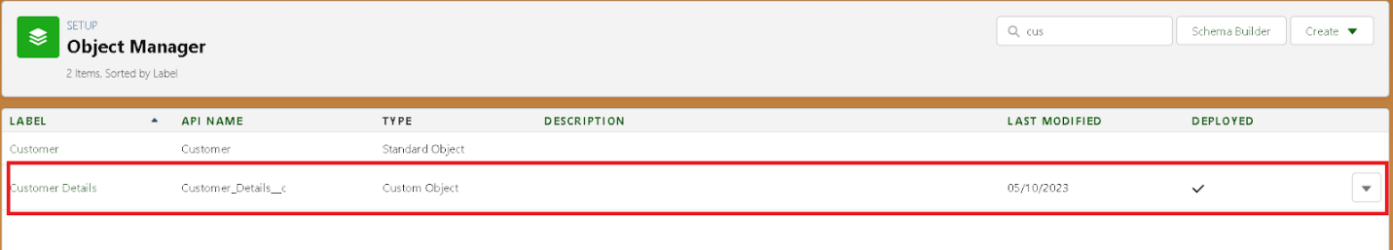

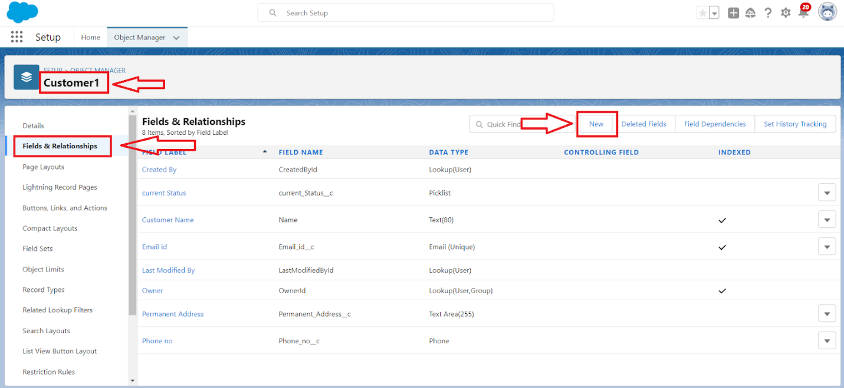

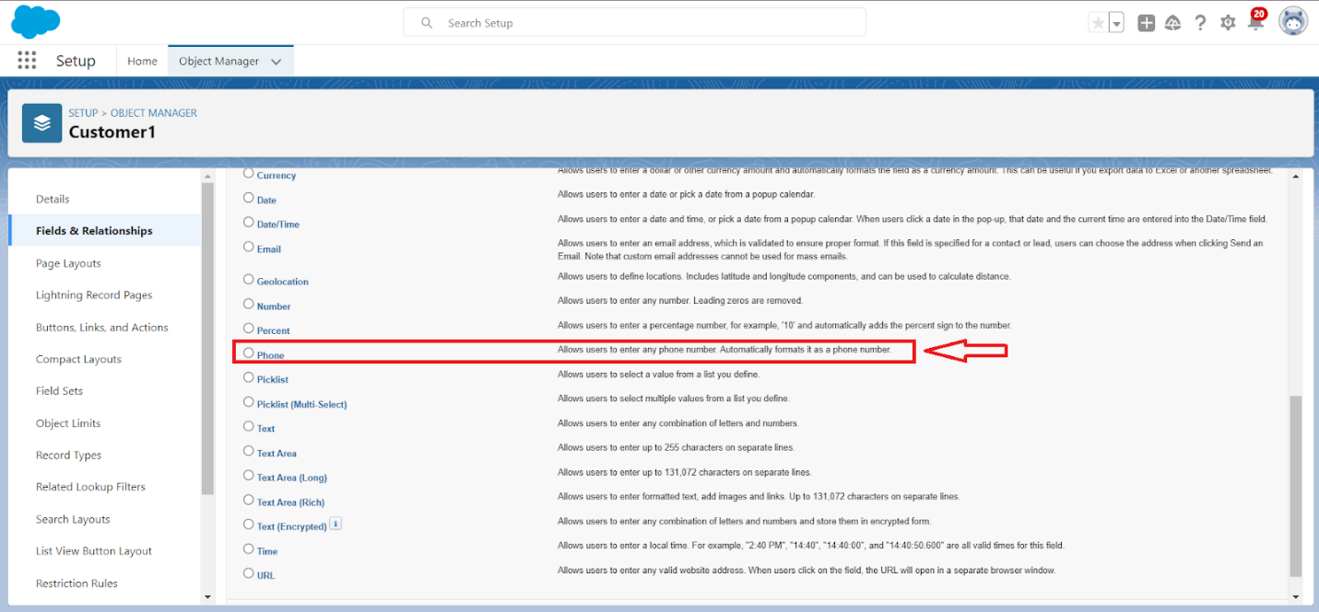

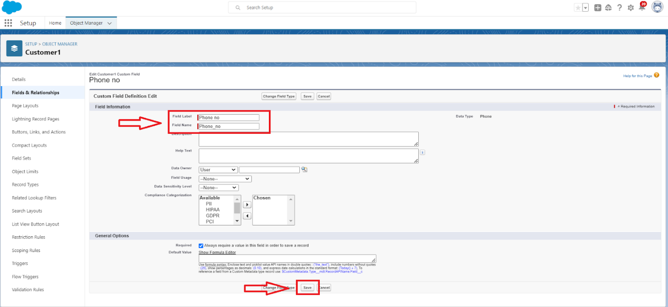

**To create another field in an object:**

1. Go to setup>> click on object manager>> type object name(customer details) in search bar>> click on object
2. Now click on “fields and relationships”, new
3. Select data type as a “e mail” and click on next
4. Field label: gmail
5. Field name: get auto generated
6. Click on next, next, save and new.

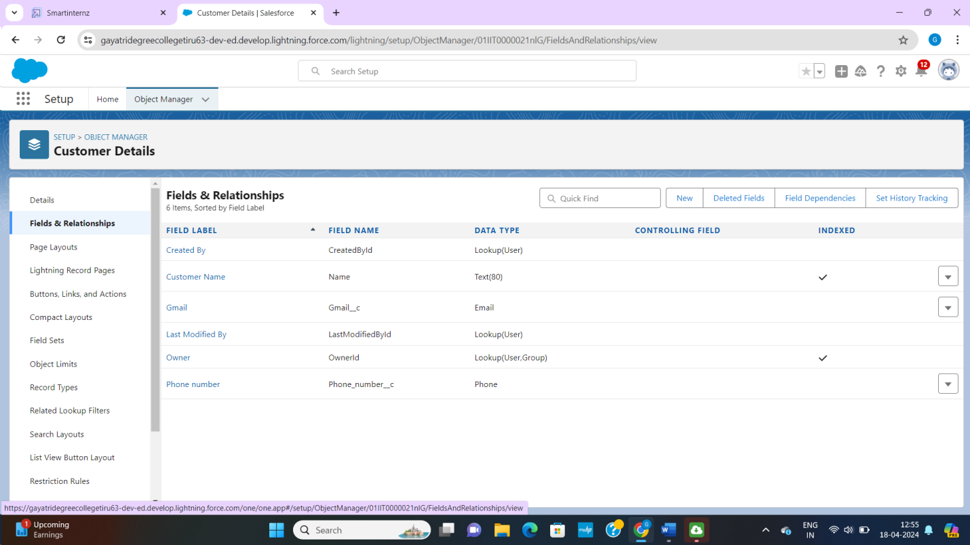

**Creation of lookup fields on appointment object:**

1. Go to setup>> click on object manager>> type object name(appointment) in search bar>> click on the object
2. Now click on “fields and relationships”, new
3. Select “lookup relationship” as data type and click next
4. Select the related object “customer details” and click next
5. Next, next, save

**Note:** make sure you complete activity 4 before continuing.

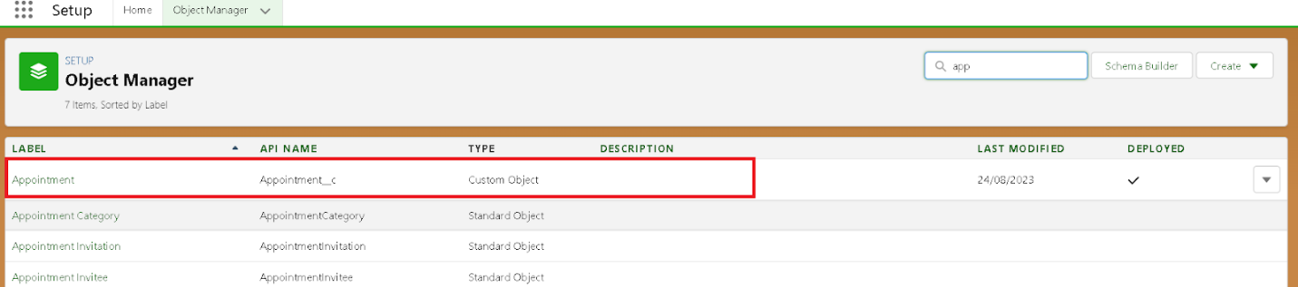

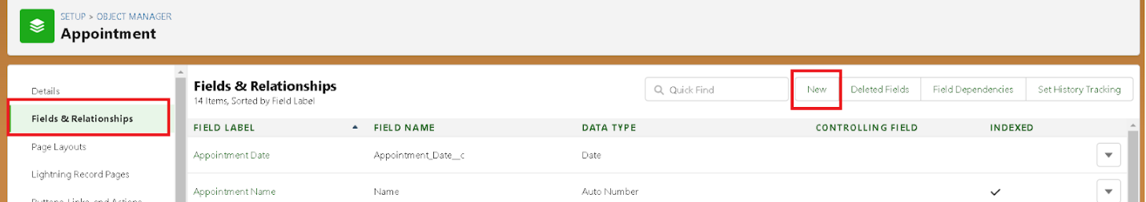

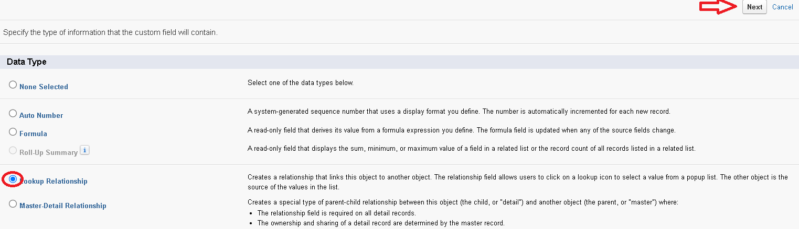

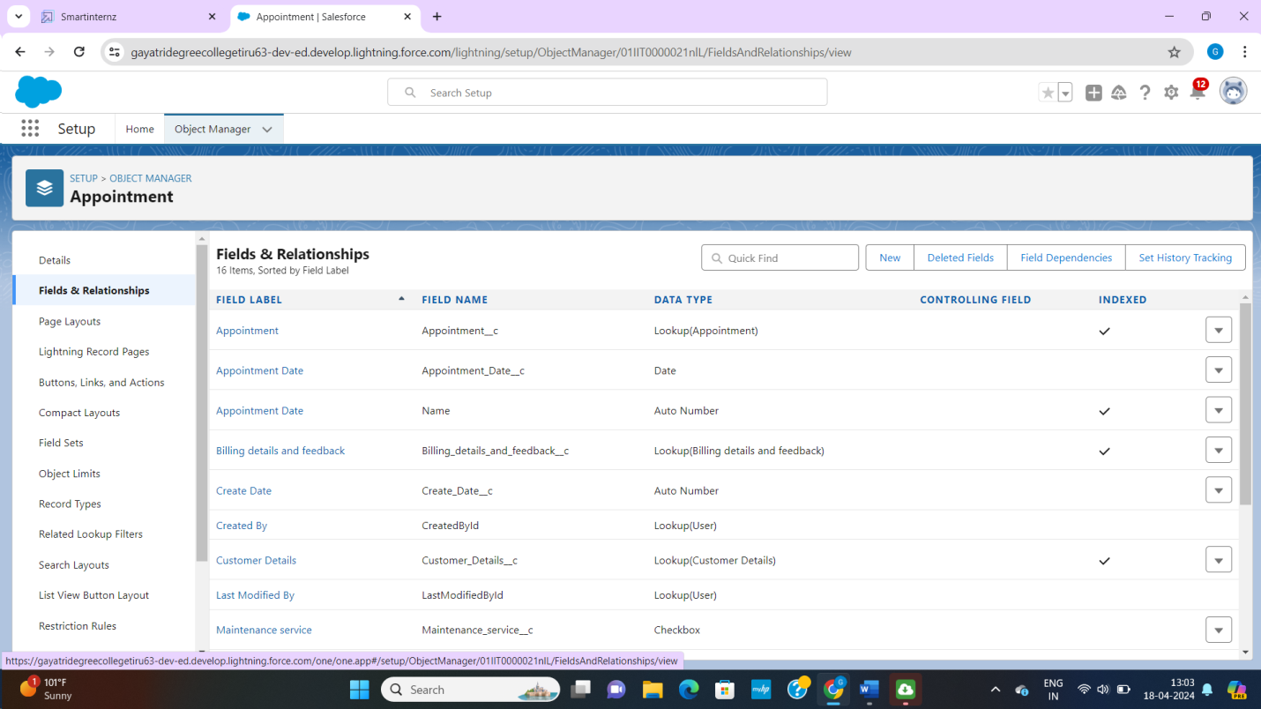

**Creation of lookup field on service records object:**

1. Go to setup>> click on object manager>> type object name(service records) in search bar>> click on object
2. Now click on “fields and relationships”, new
3. Select “lookup relationship” as data type and click next
4. Select the related object “appointment” and click next
5. Make it a required field so click required.

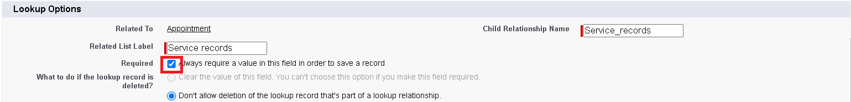

1. Scroll down for lookup filters and click on show filter settings.
2. Now add the filter criteria.
3. Field: appointment: appointment day >> operator: not equal to >> select field>> appointment created date.
4. We have to create appointment created date, we have to go object manager select appointment and click fields and relationship
5. click new, data type as auto number, label name created date, click next, next, save.
6. Filter type should be required.
7. Error message: value does not match the criteria.
8. Enable the filter by click on active
9. Next, next, save

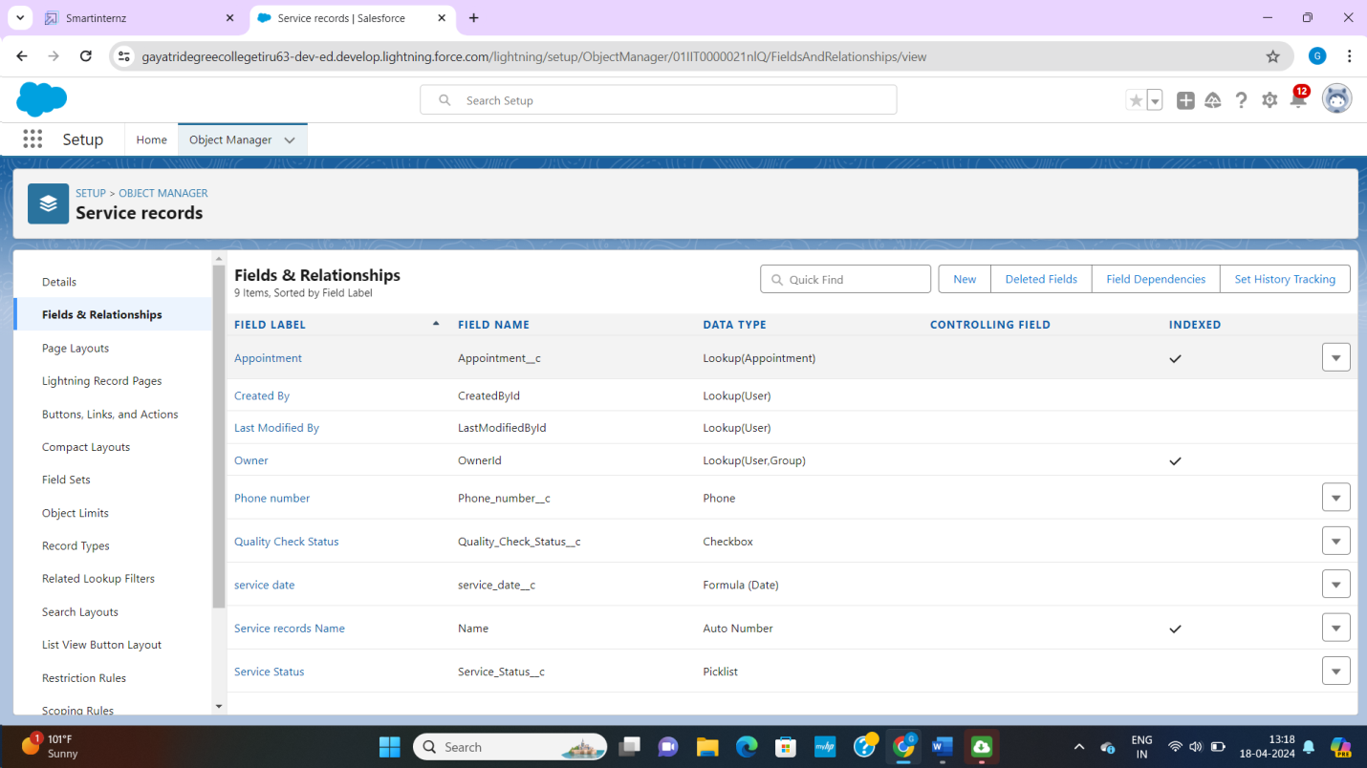

**Creation of lookup field on billing details and feedback object:**

1. Go to setup>>click on object manager>> type object name (billing details and feedback) in search bar>> click on the object.
2. Now click on “fields and relationships”, new
3. Select “lookup relationship” as data type and click and next.
4. Select the related object “service records” and click next.
5. Next, next, save

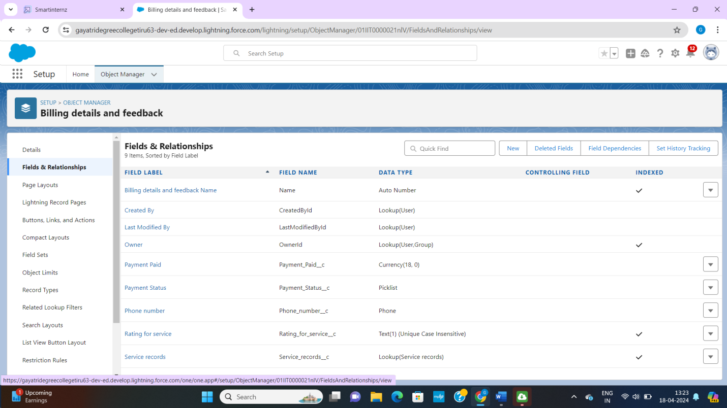

**Creation of checkbox fields**

**Creation of checkbox field on appointment object:**

1. Go to setup>> click on object manager>> type object name(appointment) in search bar>> click on the object.
2. Now click on “fields and relationships”, new
3. Select “checkbox” as data type and click next
4. Give the field label: maintenance service
5. Field name: is auto populated
6. Default value: unchecked
7. Click on next, next, save

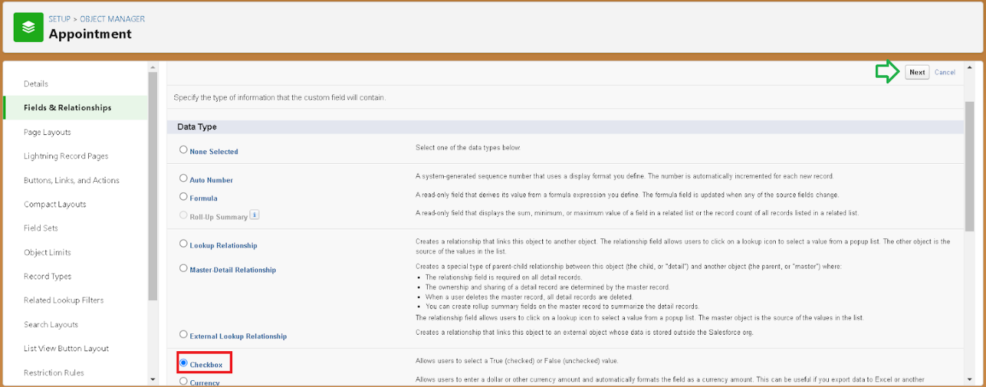

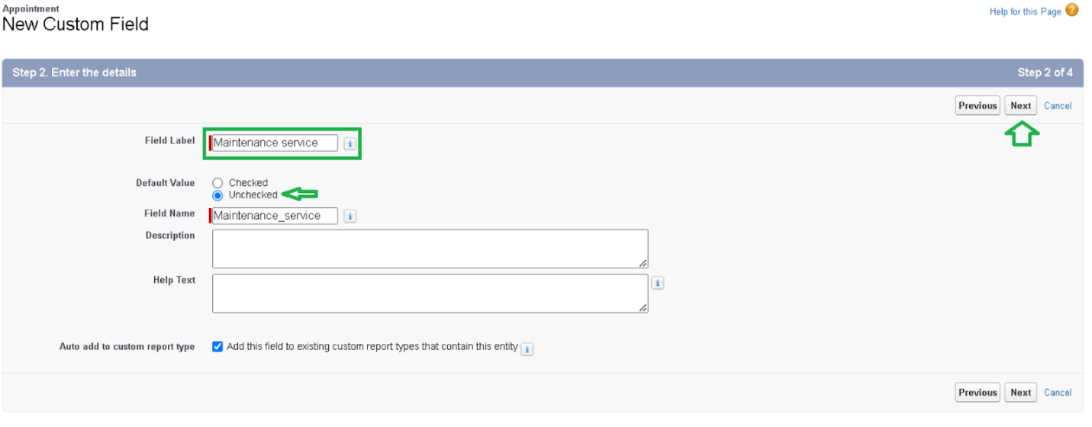

**Creation of another checkbox field on appointment object**

1. Repeat the steps from 1-3
2. Field label: repairs
3. Field name: is auto populated
4. Default value: unchecked
5. Click on next, next, save.
6. Follow the same and create another checkbox with given names
7. Field label: replacement parts
8. Field name: is auto populated
9. Default value: unchecked
10. Click on next, next, save.

**Creation of checkbox field on service records object:**

1. Go to setup>> click on object manager>> type object name(service records) in search bar>> click on object.
2. Now click on “fields and relationships”, next
3. Select “checkbox” as data type and click next.
4. Field label: quality check status
5. Field name: is auto populated
6. Default value: unchecked
7. Click on next, next, save.

**Creation of data fields**

**Creation of data field on appointment object:**

1. Go to setup>> click on object manager>> type object name(appointment) in search bar>> click on object.
2. Now click on “fields and relationships”, new
3. Select “date” as data type and click next.
4. Field label: appointment date
5. Field name: is auto populated
6. Make it as a required field by click on the required option
7. Click on next, next, save.

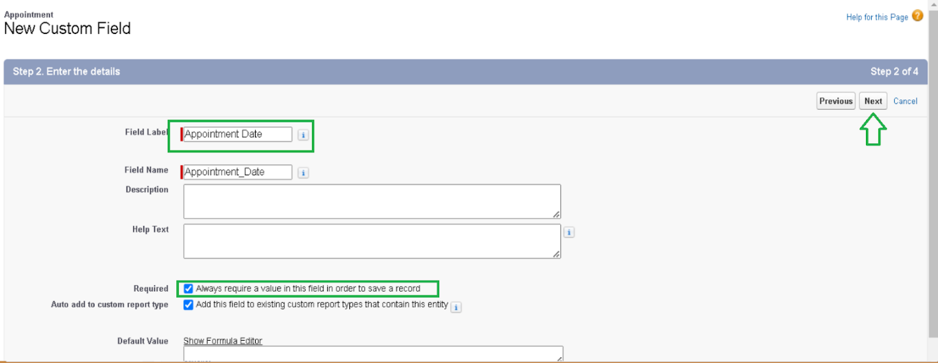

**Creation of currency fields**

**Creation of currency field on appointment object:**

1. Go to setup>> click on object manager>> type object name(appointment) in the search bar>> click on object.
2. Now click on “fields and relationships”, new
3. Select “currency” as data type and click next.
4. Field label: service amount
5. Field name: is auto populated
6. Click on next
7. Give read only for all the profiles in field level security for profile
8. Click on next, save

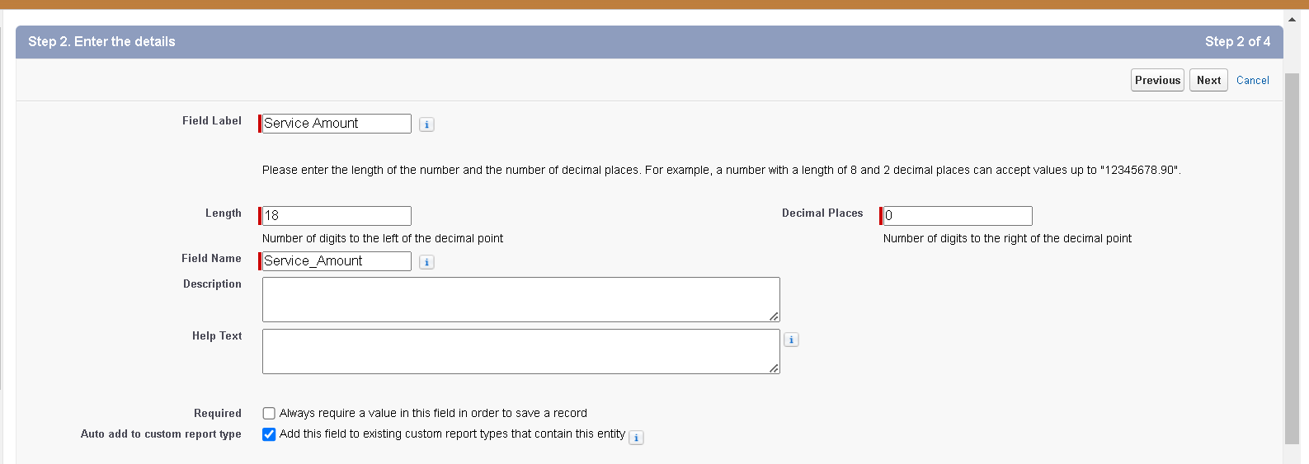

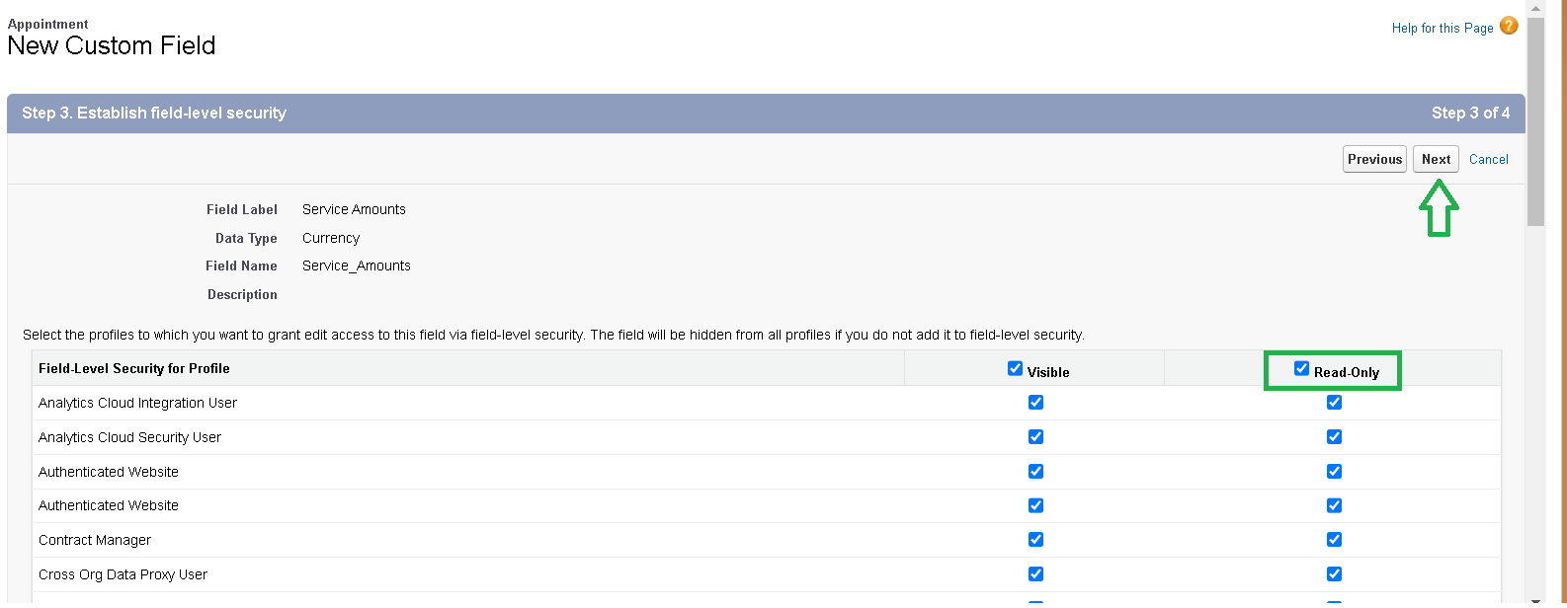

**Creation of currency field on billing details and feedback object:**

1. Follow the same steps as mentioned above in billing details and feedback object.
2. Change the label name as mentioned.
3. Field label: payment paid
4. Field name: is auto populated

**Creation of text fields**

1. Go to setup>> click on object manager>> type object name(appointment) in search bar>> click on object
2. Now click on “fields and relationships”, new
3. Select “text” as data type and click next
4. Field label: vehicle number plate
5. Field name: is auto populated
6. Length: 10
7. Make field as required and unique.
8. Click on next, next, save.

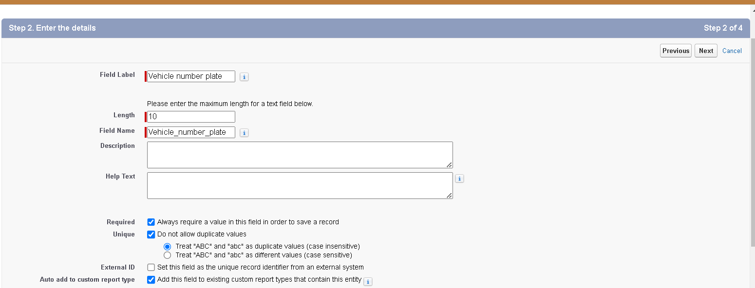

**Creation of text field in billing details and feedback object:**

1. Go to setup>> click on object manager>> type object name(billing details and feedback) in search bar>> click on object.
2. Now click on “fields and relationships”, next
3. Select “text” as data type and click next
4. Field label: rating for service
5. Field name: is auto populated
6. Length:1
7. Make field as required and unique
8. Click on next, next, save.

**Creation of picklist fields**

**Creation of picklist fields in service record object:**

1. Go to setup>> click on object manager>> type object name(service records) in search bar>> click on object
2. Click on fields and relationships, new
3. Select data type as “picklist” and click next
4. Enter field label: service status
5. Under value select “enter values, with each value separated by a new line” and enter values as shown below.
6. The value are: started, completed.
7. Click next, next, next, save.

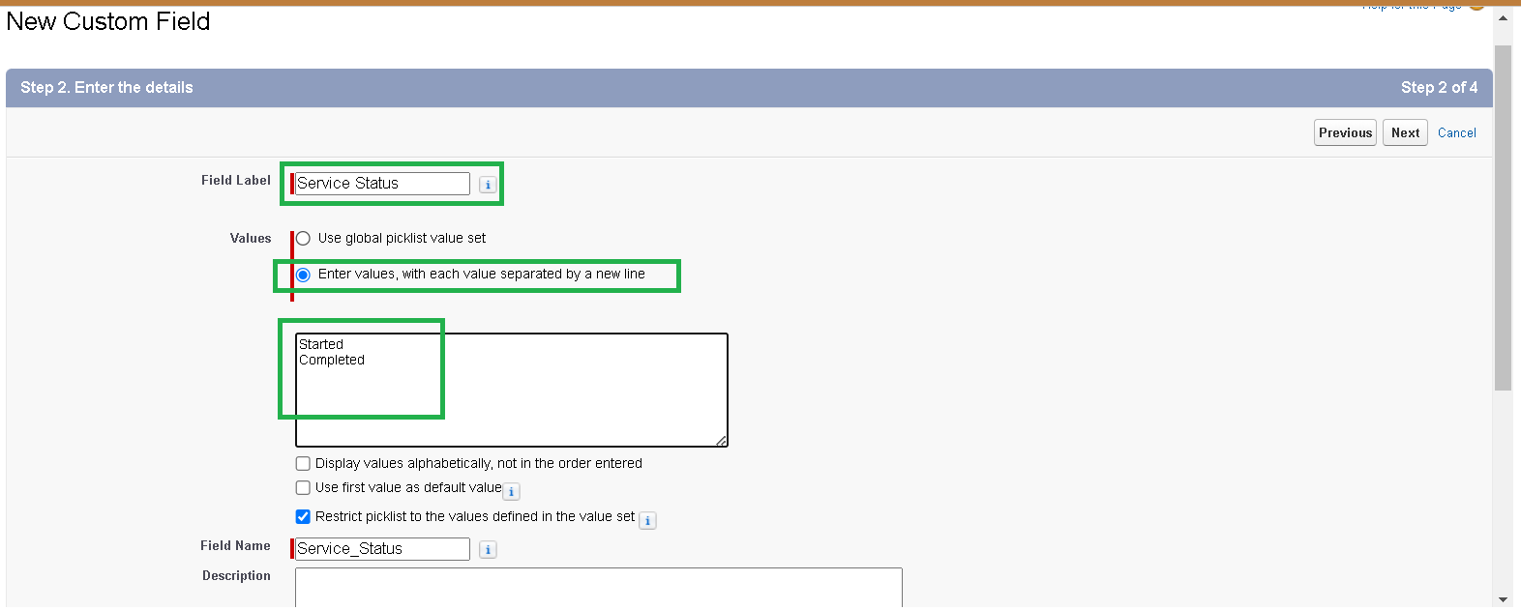

**Creation of picklist fields in billing details and feedback object:**

1. Go to setup>> click on object manager>> type object name (billing details and feedback) in search bar>> click on object
2. Click on fields and relationships, new
3. Select data type as “picklist” and click next
4. Enter field label: payment status
5. Under value select “enter values, with each value separated by a new line” and enter values as shown below.
6. The value are: pending, completed.
7. Click next, next, next, save.

**Creating formula field in service records object:**

1. Go to setup>> click on object manager>> type object name (service records) in search bar>> click on object
2. Click on fields and relationships, new
3. Select data type as “formula” and click next
4. Field label and field name as “service date” and select formula return type as “date” and click next
5. Insert field formula should be: CreatedDate.
6. Click check syntax
7. Click next, next, save

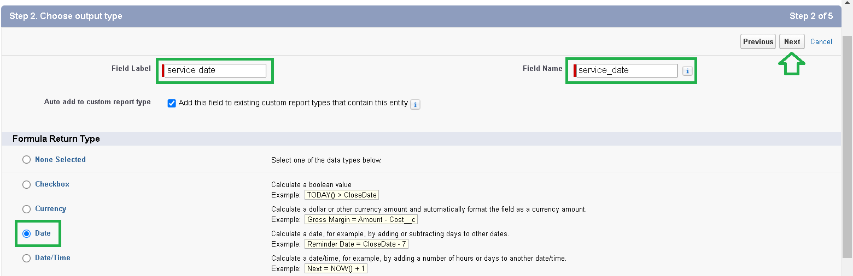

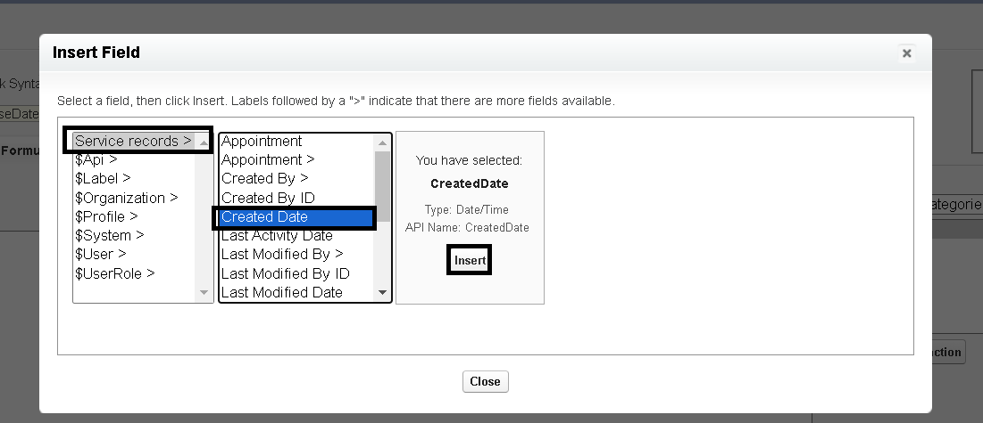

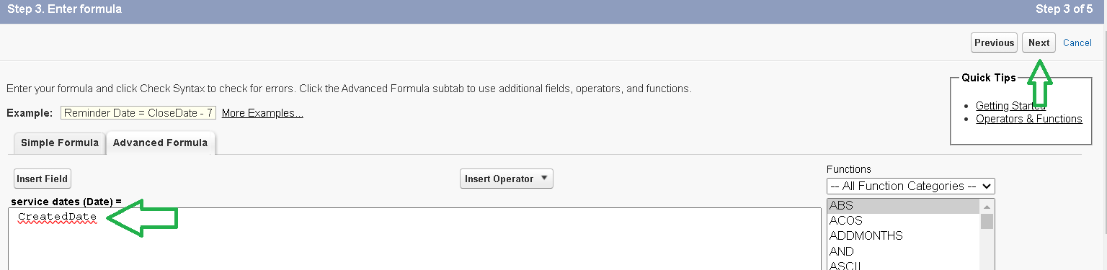

**Milestone – 06 validation rules:**

**To create a validation rule to an appointment object:**

1. Go to setup page>> click on object manager>> from drop down click edit for appointment object.
2. Click on validation rules, click new
3. Enter rule name as vehicle
4. Insert the error condition formula as
5. :

NOT(REGEX(Vechicle_number_plate__c , “[A-Z]{2}[0-9]{2}[A-Z]{2}[0-9]{4}”))

1. Enter the error message as “please enter valid number”, select the error location as field and select the field as “vehicle number plate”, and click save.

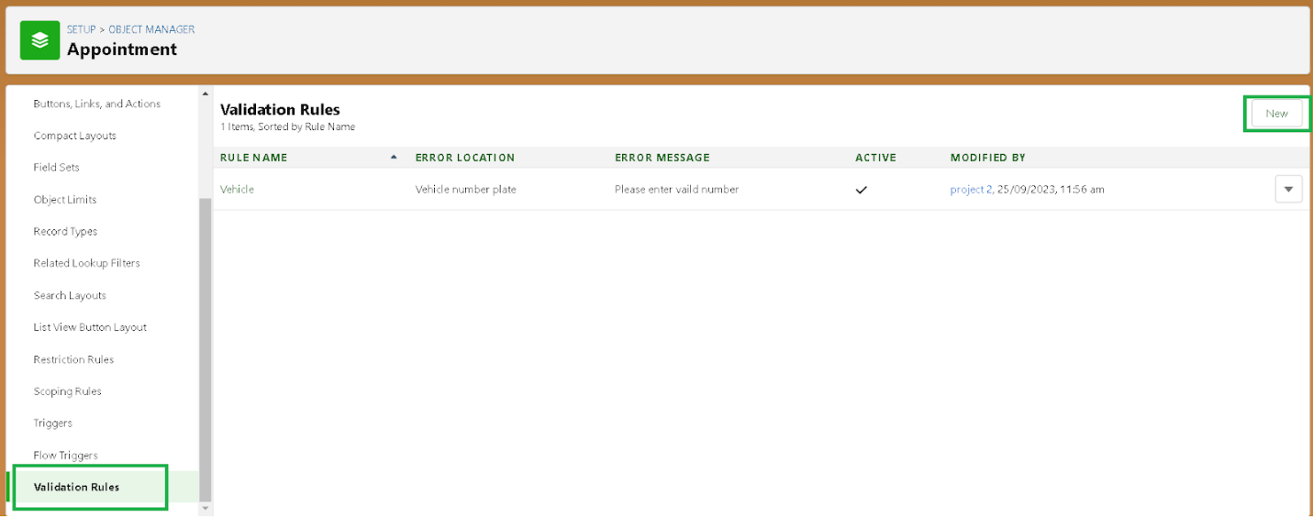

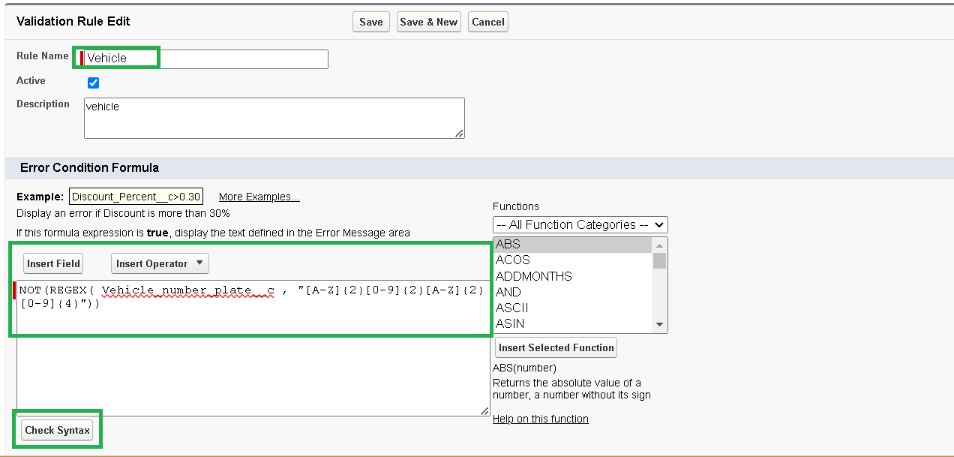

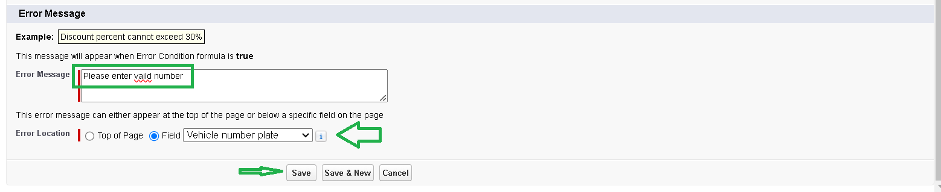

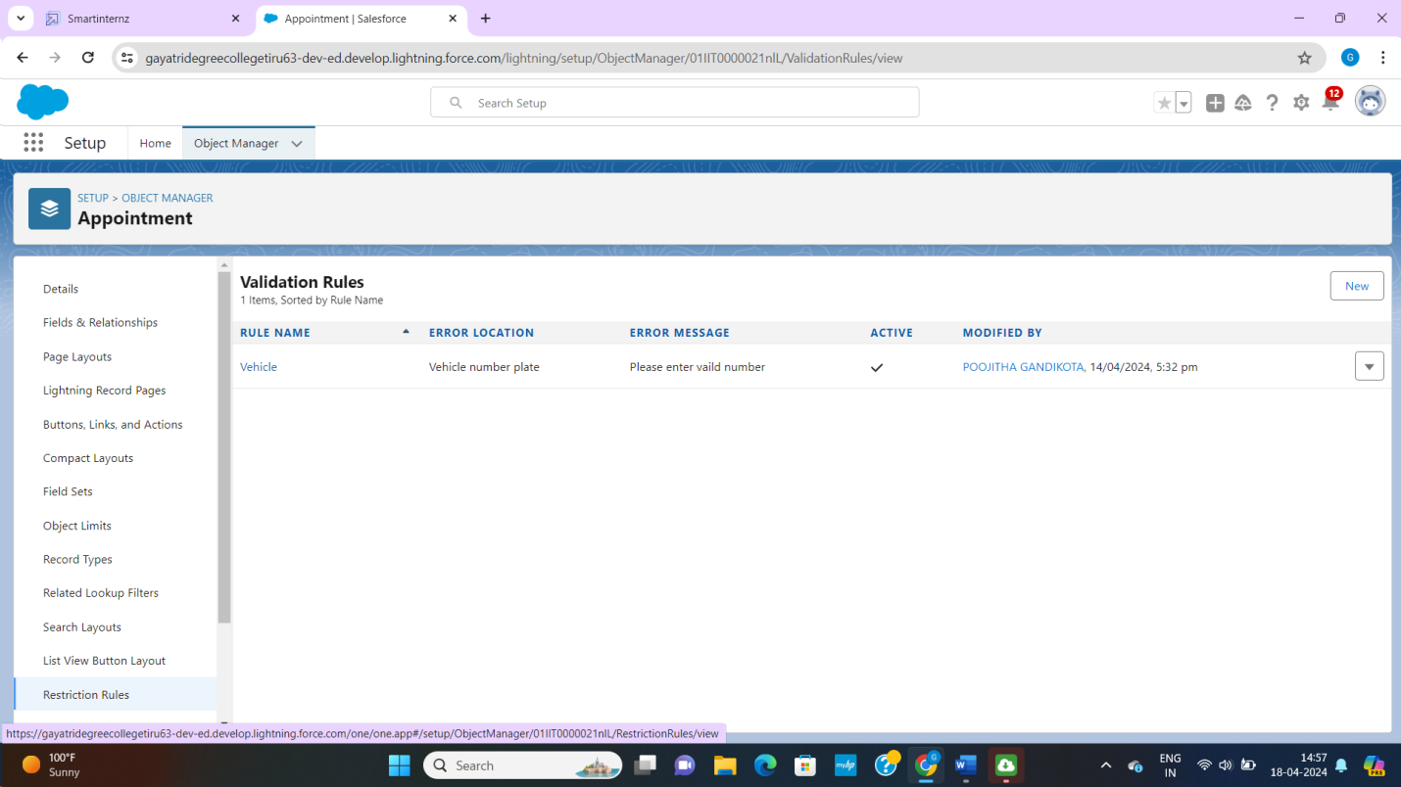

**To create a validation rules in service records object:**

1. Go to setup page>> click on object manager>> from drop down click edit for service records object.
2. Click on validation rules, click new
3. Enter rule name as “service_status_note”
4. Insert the error condition formula as:

NOT(ISPICKVAL(Service_Status__c , “completed”))

1. Enter the error message as “still it is pending”, select the error location as field and select the field as “service status”, and click save

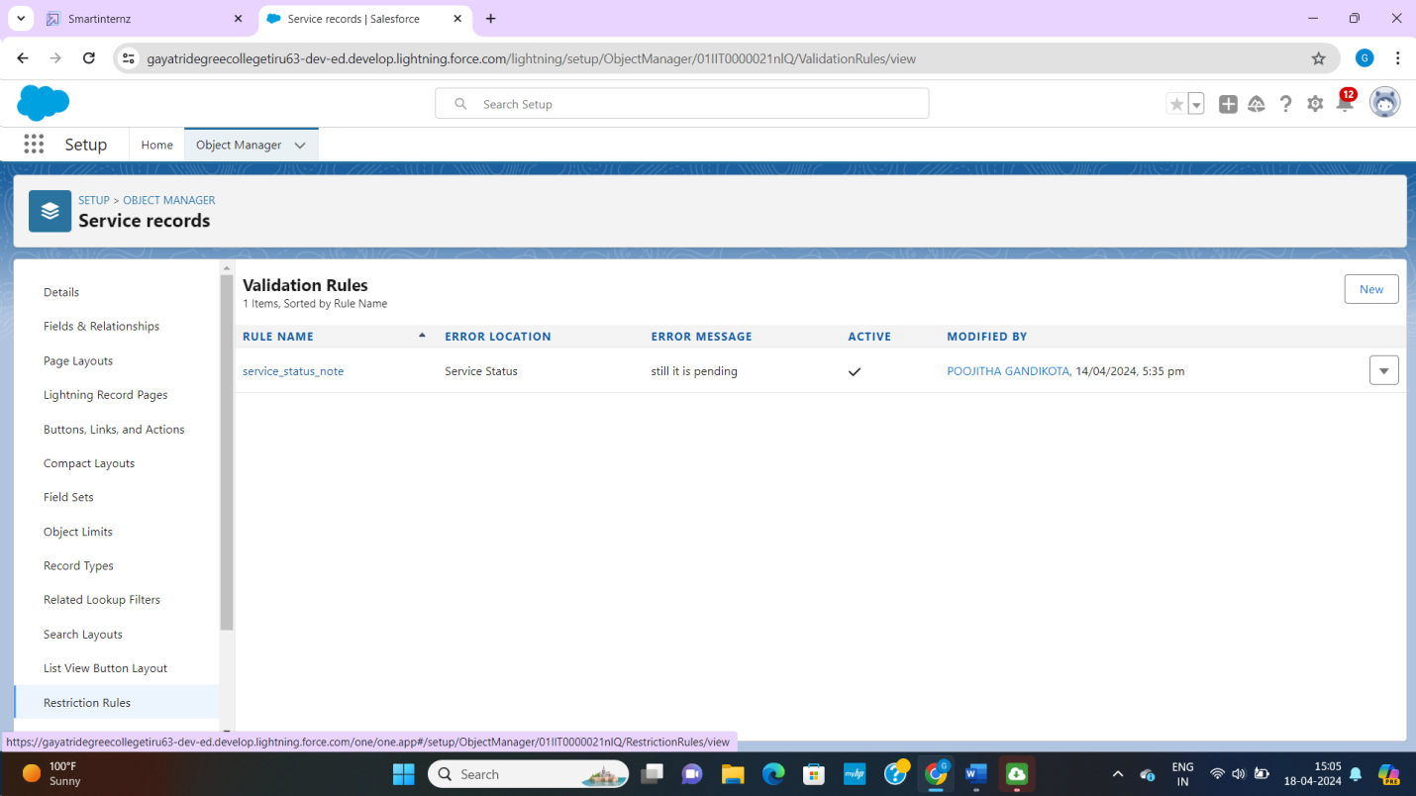

**To create a validation rule to an billing details and feedback object:**

1. Go to setup page>> click on object manager>> from drop down click edit for billing details and feedback object.
2. Click on validation rules, click new
3. Enter rule name as “rating_should_be_less_than_s”
4. Insert the error condition formula as:

NOT(REGEX(Rating_for_service_c , “[1-5]{1}”}}

1. Enter the error message as “rating should be from 1 to 5”, select the error location as field and select the field as “rating for service”, and click save.

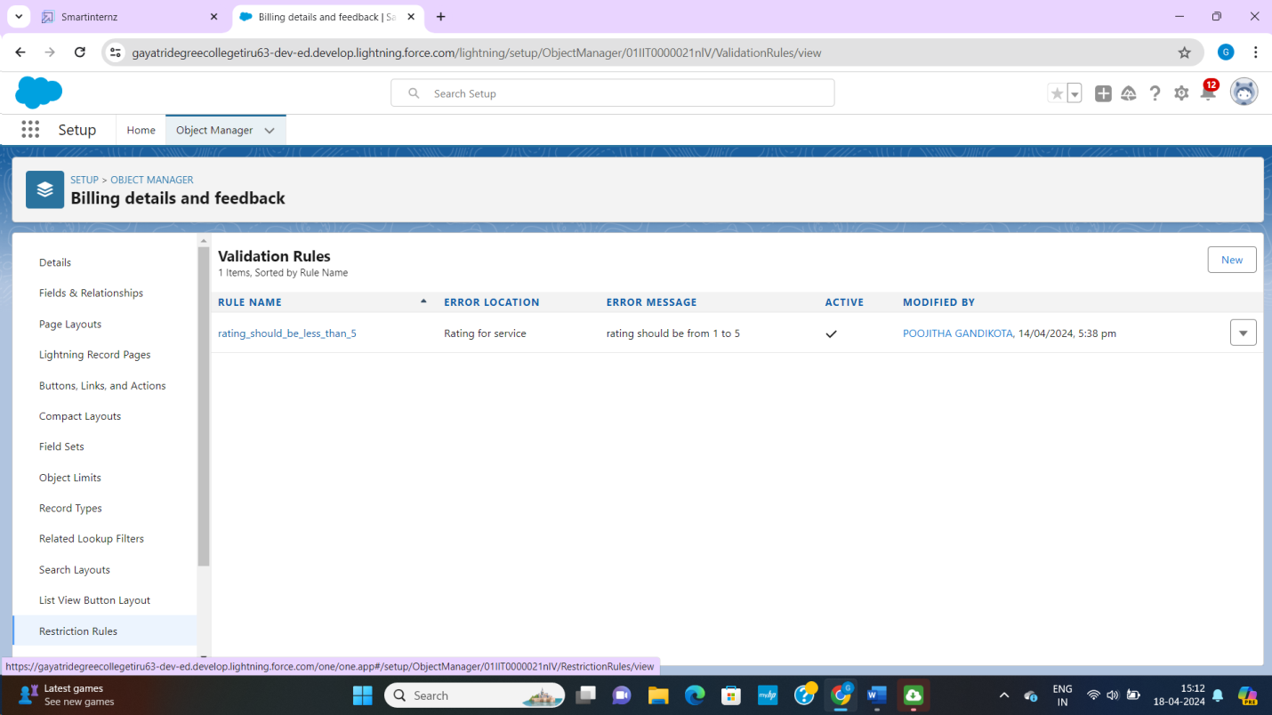

**Milestone – 07 duplicate rules**

**To create a matching rules to an customer details object:**

1. Go to quick find box in setup and search for matching rules
2. Click matching rule, click on new
3. Select the object customer detail and click next

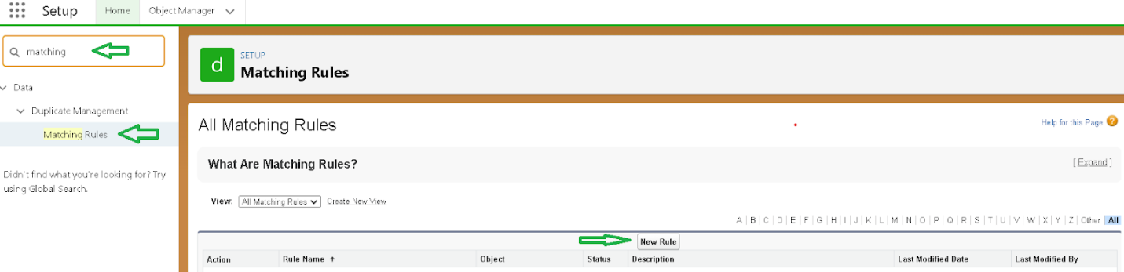

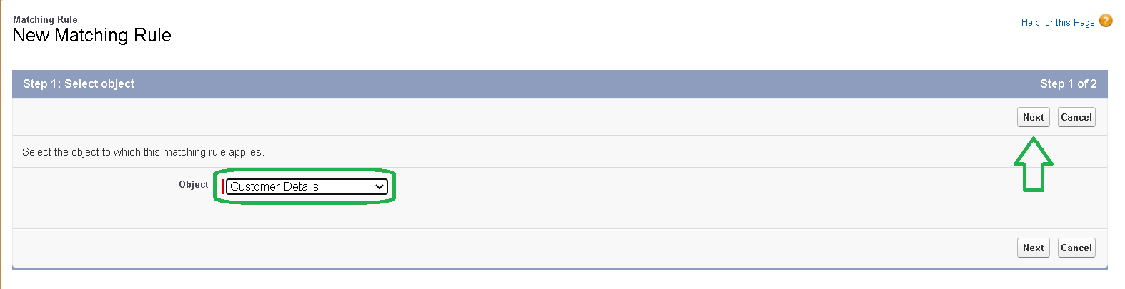

1. Rule name: matching customer details
2. Unique name: is auto populated
3. Define the matching criteria as
4. Field matching methods

Gmail exact

Phone number exact

1. Click save and after saving click on activate.

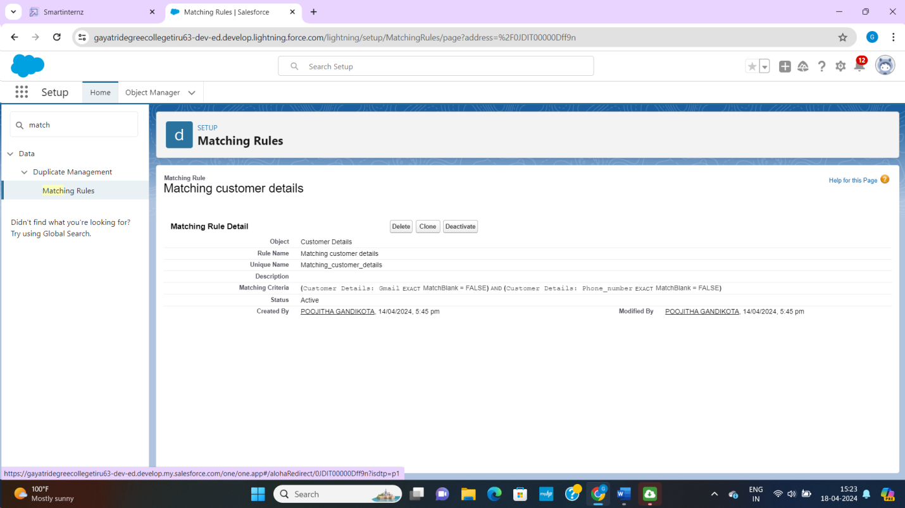

**To create a duplicate rule to an customer details object**

1. Go to quick find box in setup and search for duplicate rules.
2. Click on duplicate rule>> click on new rule>> select customer details object

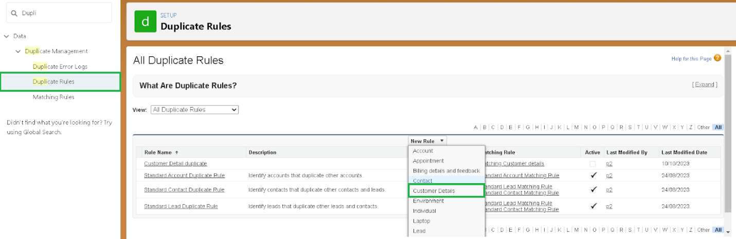

1. Rule name as: customer detail duplicate
2. Scroll a little in matching rule section
3. Select matching rule: matching customer details
4. Click on save after saving the duplicate rule, click on activate.

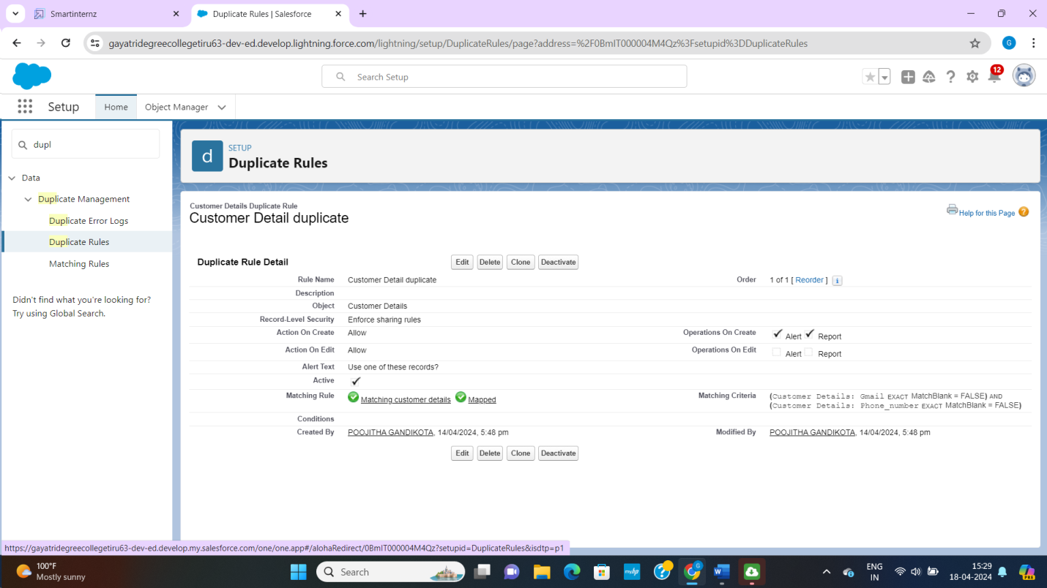

**Milestone – 08 profiles**

**Manager profiles**

**To create a new profile:**

1. Go to setup>> type profiles in quick find box>> click on profiles>> clone the desired profile(standard user)>> enter profile name(manager)>> save
2. While still on the profile page click edit
3. Select the custom app settings as d default for the garage management application.
4. Scroll down to custom object permission and give access permissions for appointments, billing details and feedback, service records and customer details objects.
5. Changing the session times out after should be “8 hours of inactive”.
6. Change the password policies as mentioned
7. User password expire in should be “never expires”
8. Minimum password length should be “8” and click save

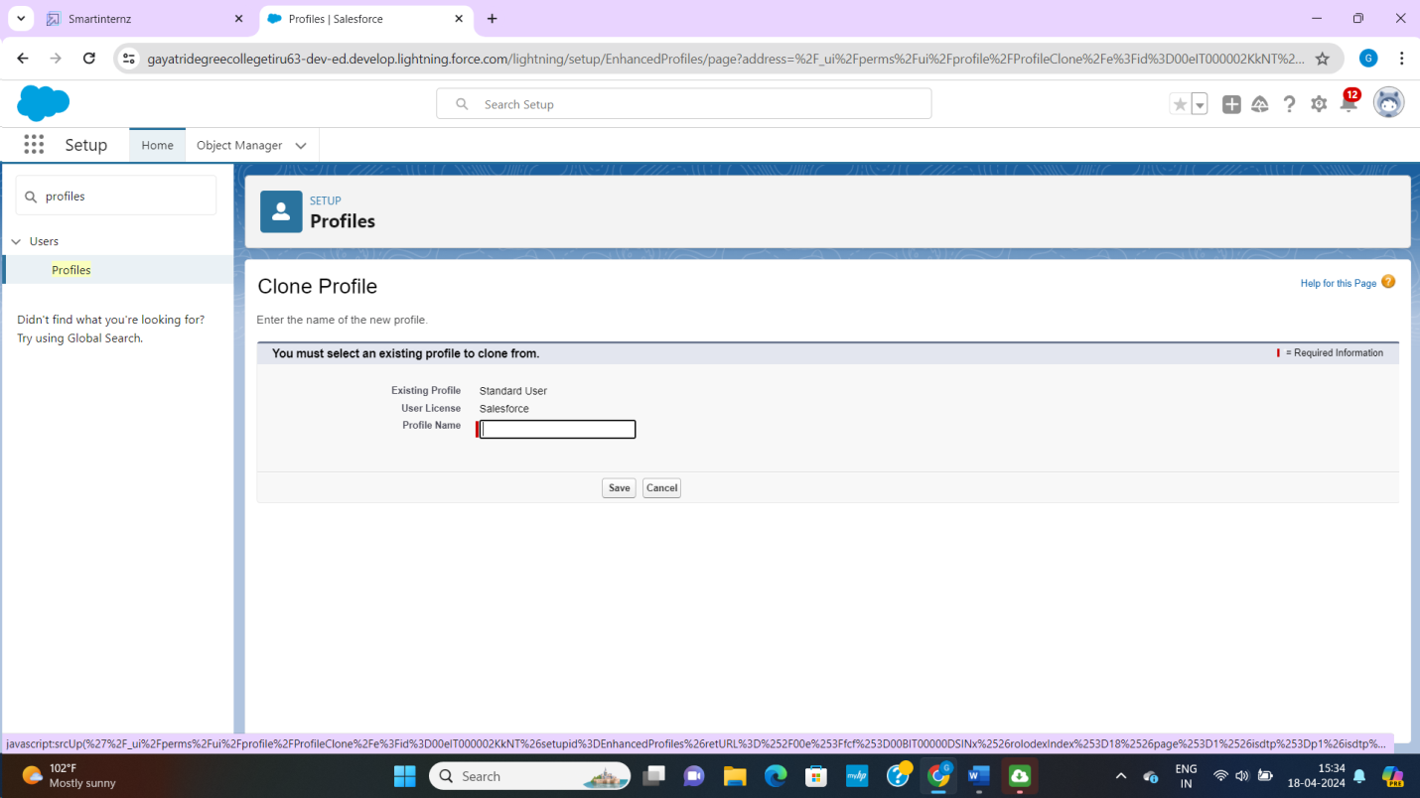

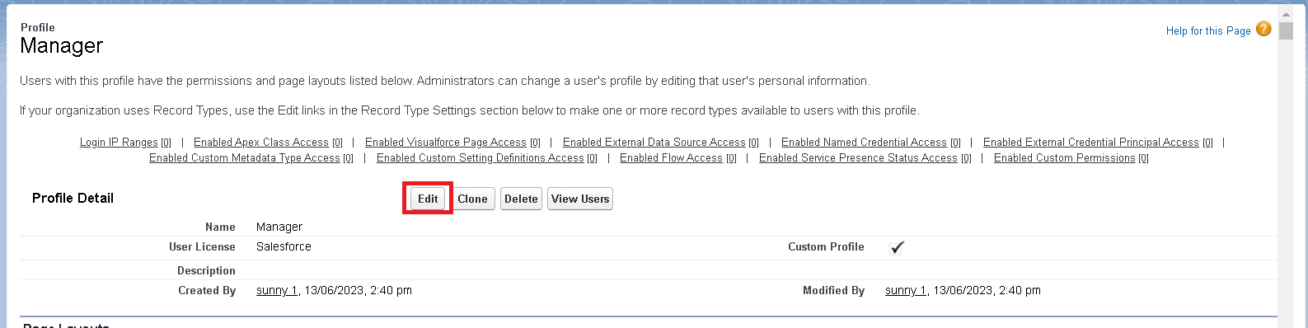

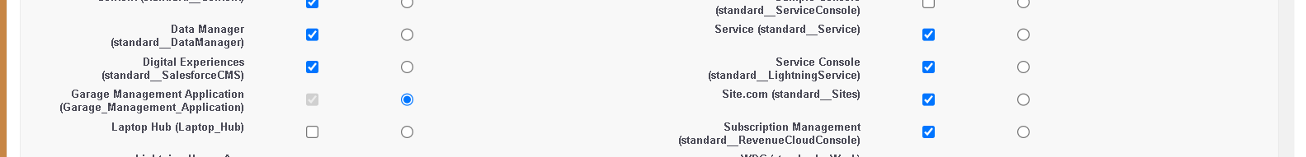

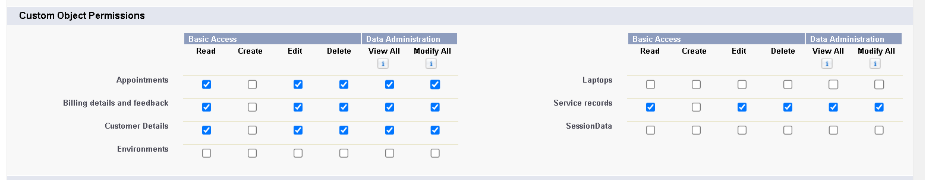

**Sales person profile:**

1. Go to setup>> type profile in quick find box>> click on profiles>> clone the desired profile(salesforce platform user)>> enter profile name (salesperson)>>save
2. While still on the profile page, then click edit
3. Select the custom app settings as default for the garage management application.
4. Scroll down to custom object permission and give access permission for appointments, billing details and feedback, service records and customer details objects as mentioned in the below diagram
5. Click save

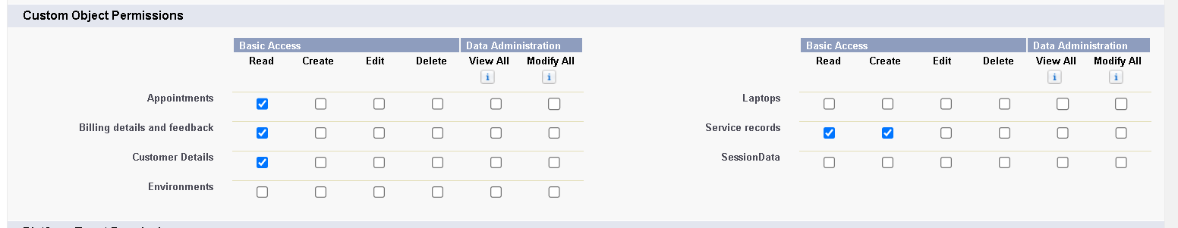

**Milestone – 09 role and role hierarchy**

**Creating manager role**

1. Go to quick find>> search for roles>> click on setup roles.

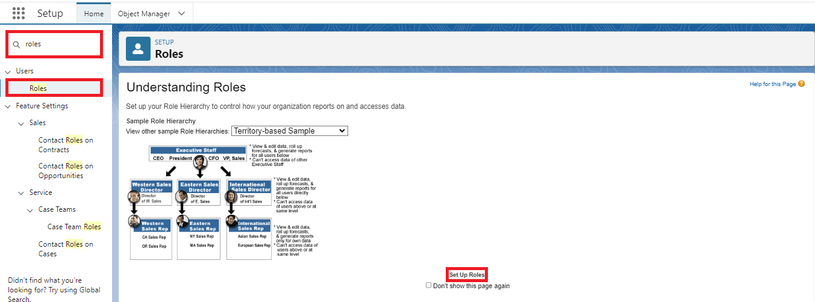

1. Click on expand all and click on add role under whom these role works

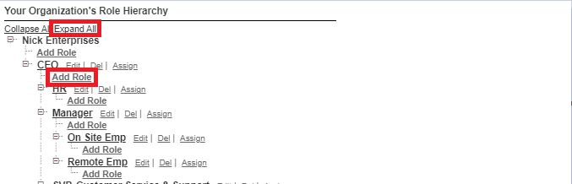

1. Give label as “manager” and role name gets auto populated. then click on save

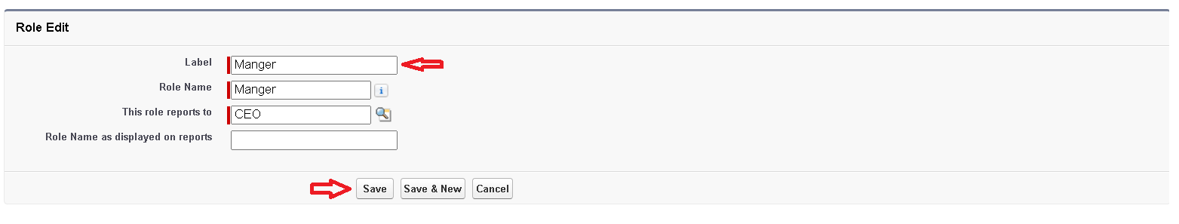

**Creating another roles**

**Creating another two roles under manager**

1. Go to quick find>> search for roles>> click on setup roles
2. Click plus on CEO role, and click add role under manager.
3. Give label as “sales person” and role name gets auto populated
4. Then click on save

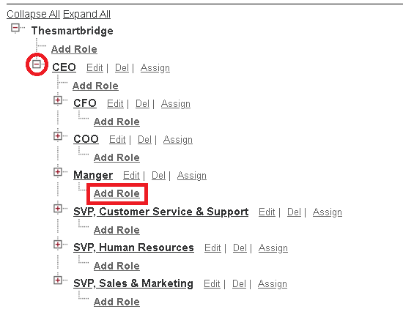

**Milestone – 10 users**

**Create users**

1. Go to setup>> type user in quick find box>> select user>> click new user.
2. Fill in the fields
3. First name: niklaus
4. Last name: mikaelson
5. Alias: give a alias name
6. Email id: give your personal email id
7. User name: user name should be in this form: [text@text.text](mailto:text@text.text)
8. Nick name: give a nick name
9. Role: manager
10. User licence: salesforce
11. Profile: manager
12. Save

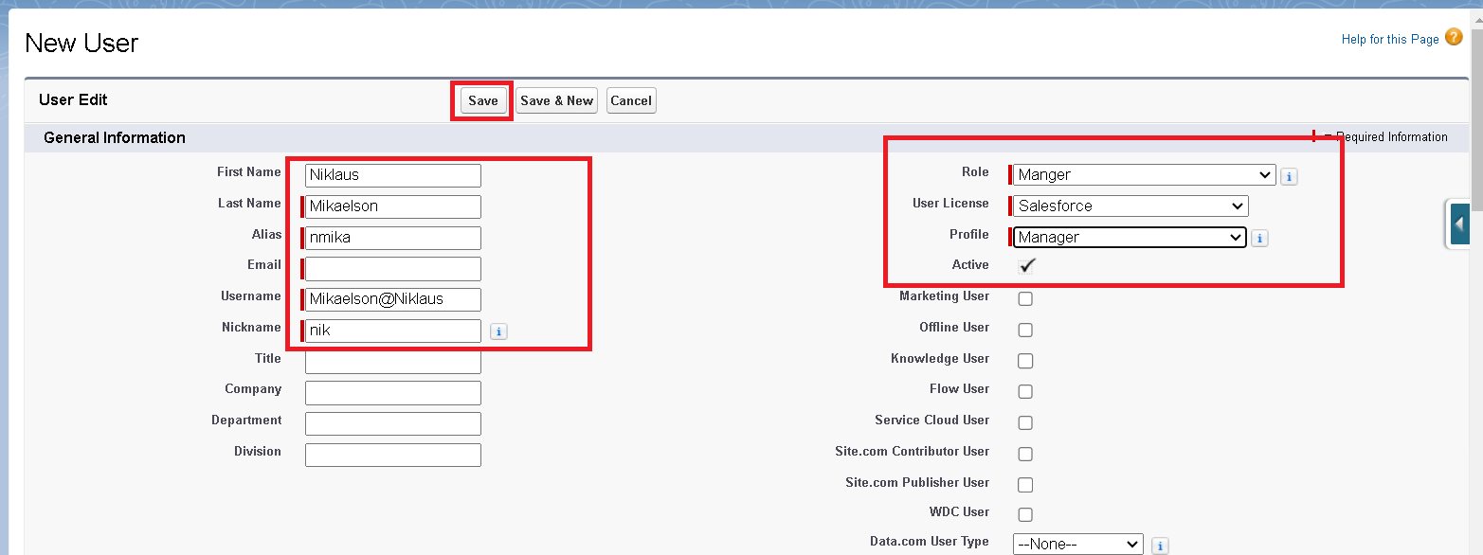

**Creating another users**

1. Repeat the steps and create another user using
2. Role: sales person
3. User licence: salesforce platform
4. Profile: sales person

**Note:** create atleast three users with these permissions.

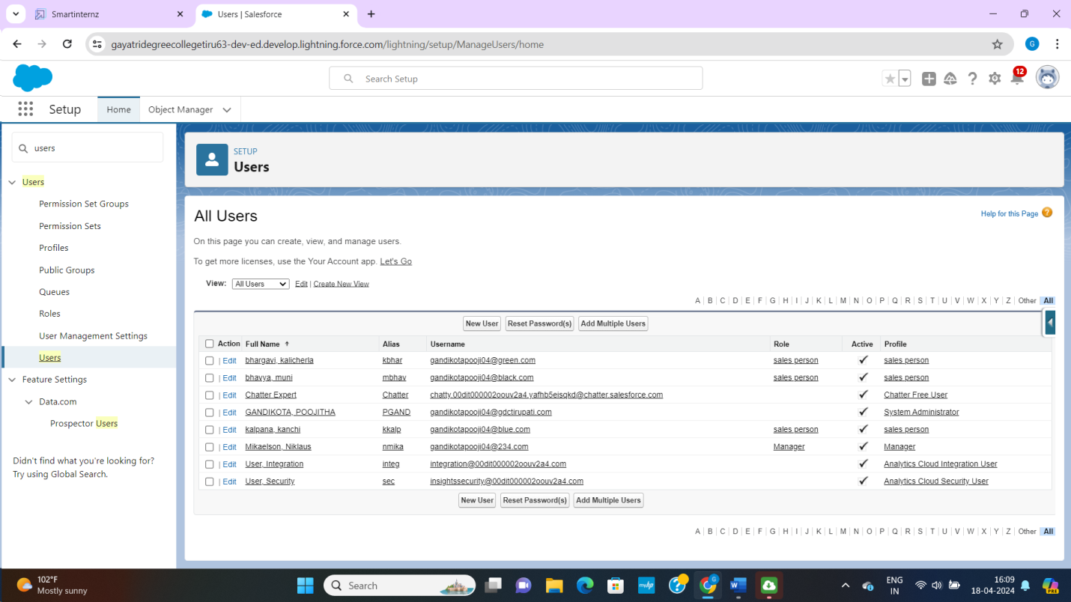

**Milestone – 11 public groups**

**Creating new public groups**

1. Go to setup>> type user in quick find box>> select public groups>> click new
2. Give the label as “sales team”
3. Group name is auto populated
4. Search for roles
5. In available members select sales person and click on add it will be moved to selected members
6. Click on save

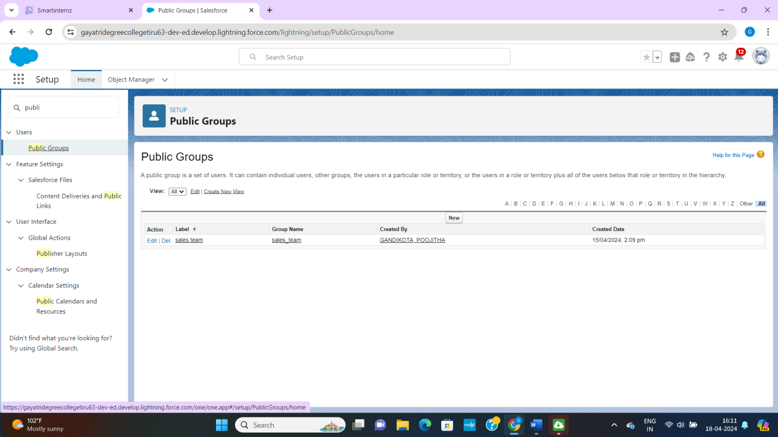

**Milestone – 12 sharing settings**

**Creating sharing settings**

1. Go to setup>> type users in quick find box>> select sharing settings>> click edit
2. Change the OWD settings of the service record object to private as shown in figure

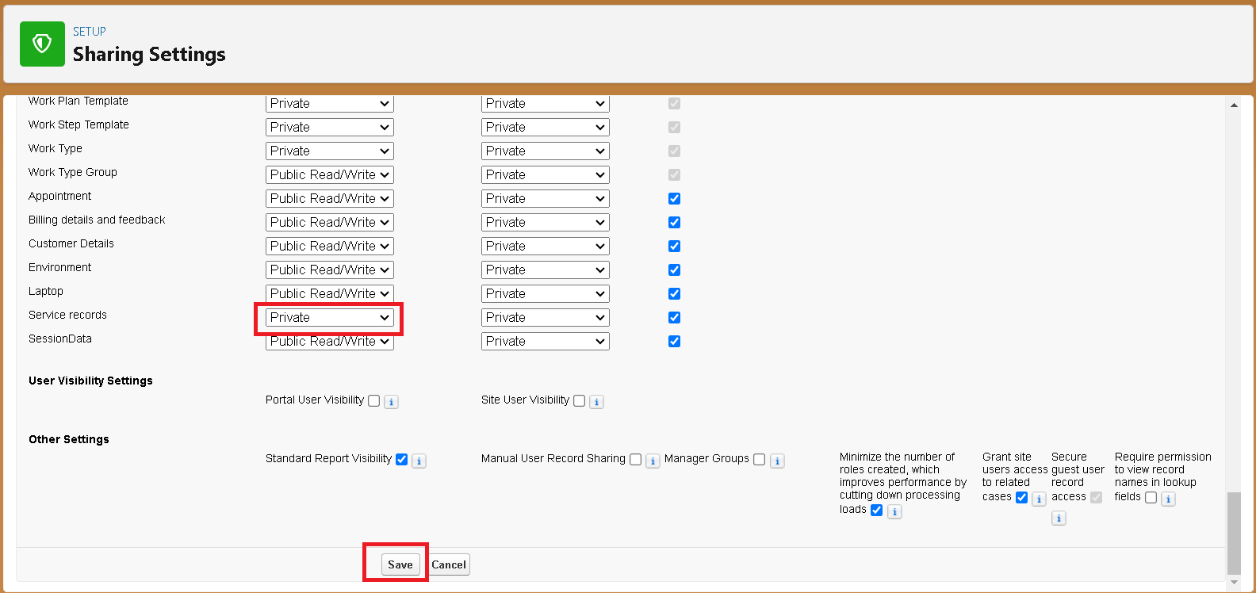

1. Click on save and refresh
2. Scroll down a bit, click new on service records sharing rules
3. Give the label name as “sharing setting”
4. Rule name is auto populated
5. In step 3: select which record to be shared, members of “role”>> “sales person”
6. In step 4: share with, select “roles”>> “manager”
7. In step 5: change the access level to “read/write”.
8. Click on save.

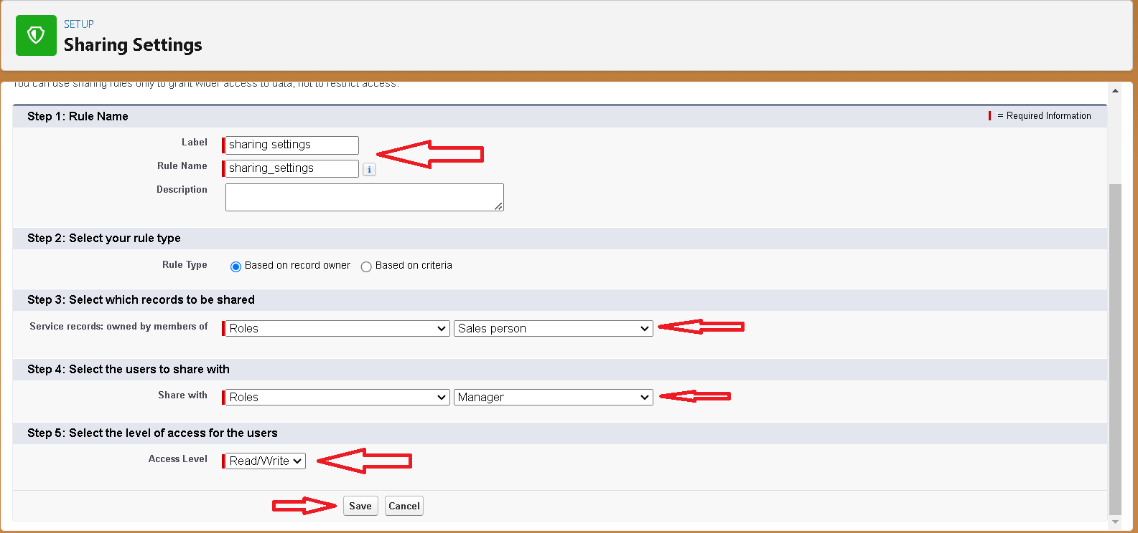

**Milestone –13 Flows**

1. Go to setup>> type flow in quick find box >> click on the flow and select the new flow.
2. Select the record triggered flow and click on create.
3. Select the object as “billing details and feedback” in the dropdown list.
4. select the triggered flow when “a record is created or updated”.
5. Select the optimizes flow for “actions and related records” and click on done.
6. Under the record triggered flow click on “+” symbol and in the drop down list select the “update records element”.
7. Label name: amount update
8. Api name: is auto populated
9. Set a filter condition: “all conditions are met(AND)”

10.Field:payment_status_c

11.Operator: equals

12.Value: completed

13. And set field value for the billing detail and feedback record

14. Field: payment_paid_c

15. Value: {!$Record.Service_records__r.Appointment__r.Service_Amount__c}

16. click done

17. Before creating another element. Create a new resource from toolbox from top left.

18. click on new resources, and select text template.

19. enter the api name: “alert”

20. change the view to plain text

21. I n body field paste the syntax in given below

Dear {!$Record.Service_records__r.Appointment__r.Customer_Name__c.Name},

I hope this message finds you well. I wanted to take a moment to express my sincere gratitude for your recent payment for the services provided by our garage management team. Your prompt payment is greatly appreciated, and it helps us continue to provide top-notch services to you and all our valued customers.

Amount paid: {!$Record.Payment_Paid__c}

Thank you for Coming.

22. click on done.

23. now click on add elements, select action.

24. In action bar in that search the “send email” and click on it.

25. label name as “email alert”

26. API name will autopopulated.

27. Enable the body in set input values for the selected action.

28. select the text template that created body:{!alert}

29. Include the recipient address list as alert

30. Include the subject as “Thank you for your payment – garage management”.

31. click done.

32. click on save. Give the flow label as billing amount flow and api name is auto populated.

33. click save and activate.

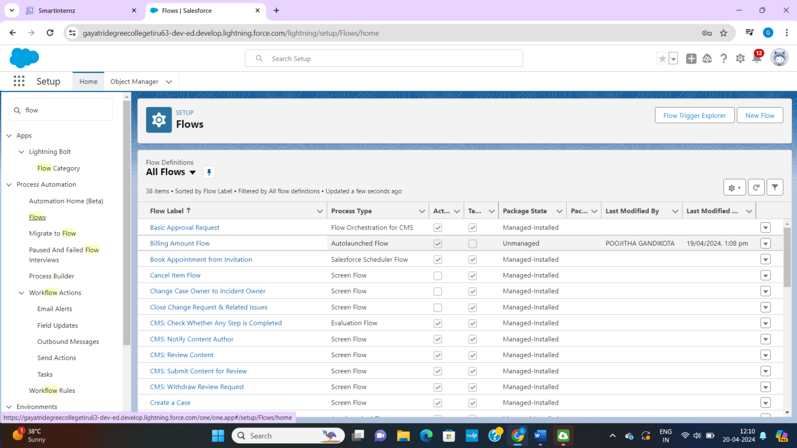

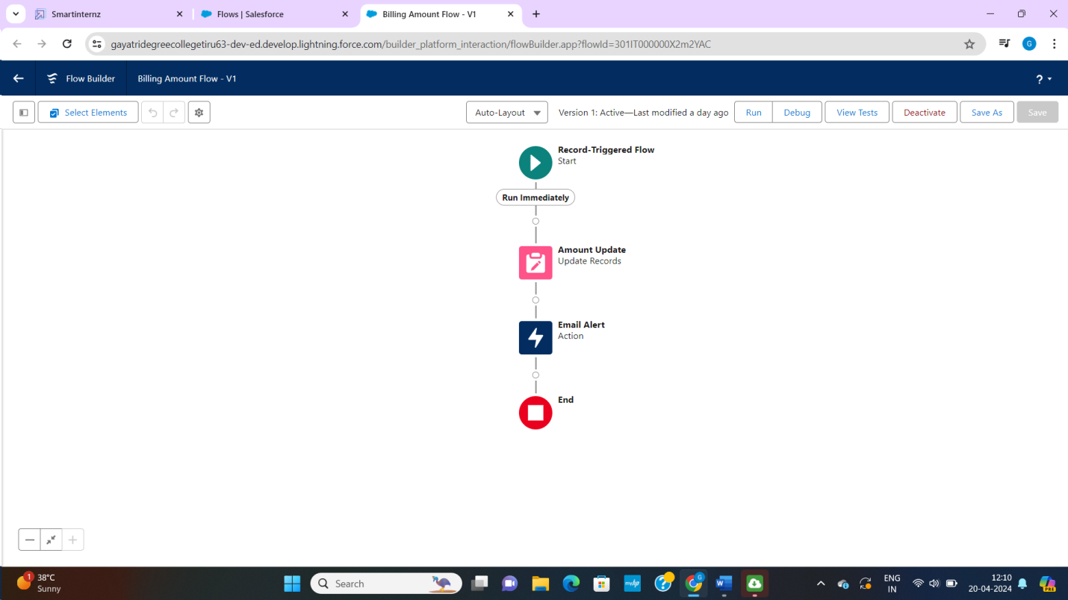

**Milestones – 14 Apex Trigger**

**Apex Handler:**

UseCase: this use case work for amount distribution for each service the customer selected the vehicle.

1. Login to the respective trailhead account and navigate to the gear icon in the top right corner.
2. Click on the Developer console. Now you will see a new console window.
3. In the toolbar, you can see FILE. Click on it and navigate to new and create Newapex class.
4. Name the class as “AmountDistributionHandler ”.

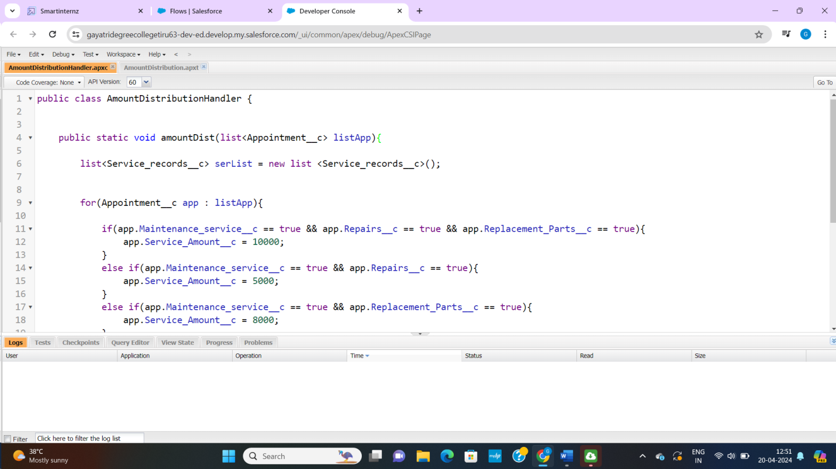

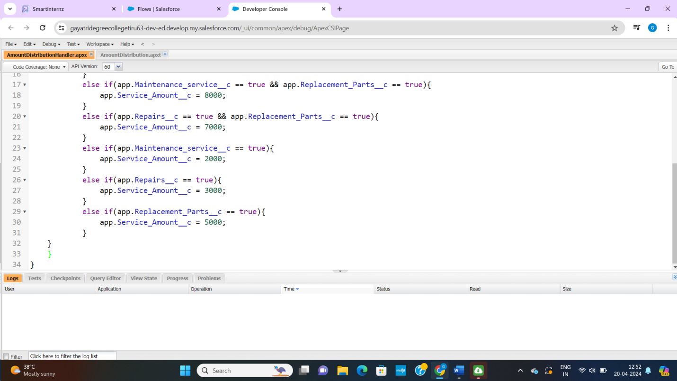

**Trigger Handler:**

**How to create a new trigger:**

1. While still in the trailhead account, navigate to the gear icon in the top right corner.
2. Click on developer console and you will be navigated to a new console window.
3. Click on file menu in the tool bar and click on new trigger.
4. Enter the trigger name and the object to be triggered.
5. Name: amountdistution
6. sObject: appointment__c

**syntax for creating trigger:**

The syntax for creating trigger is:

Trigger [trigger name] on [object name] (before/after event)

{

}

In this project, trigger is called whenever the particular record sum exceed the threshold i.e, minimum business requirement value. Then the code in the trigger will get executed.

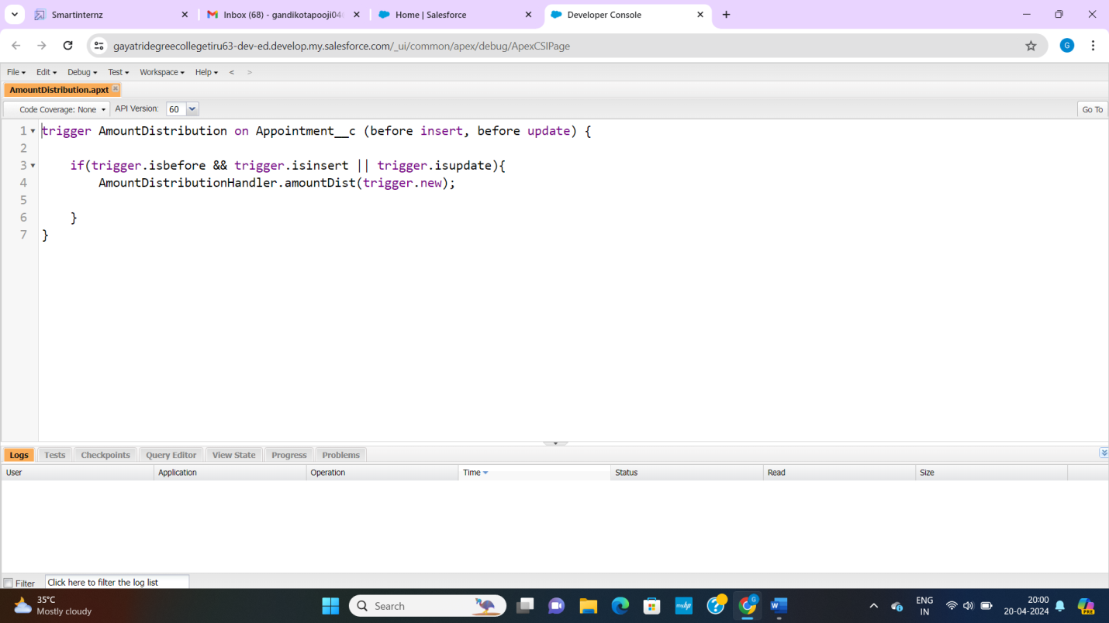

**Milestone – 15 Reports:**

**Create a reports folder:**

1. click on the app launcher and search for reports
2. click on the report tab, click on new folder
3. Give the folder label name as “garage management folder”.Folder unique name will be auto populated.
4. Click save.

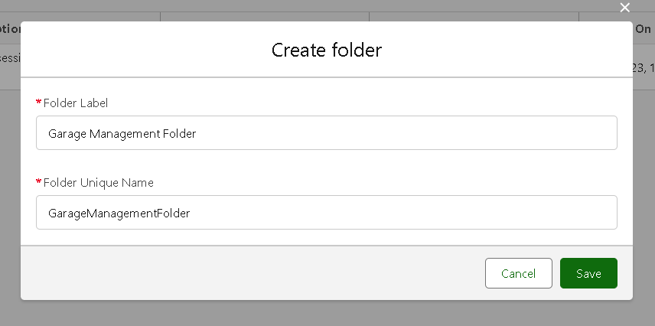

**Sharing a report folder:**

1. Go to the app >> click on the reports tab.
2. Click on the all folder, click on the drop down arrow for Garage management folder, and click on share.
3. Select the share with as “roles”, in name field search for “manger”, give “view” as access for the role.
4. Then click share and click on done.

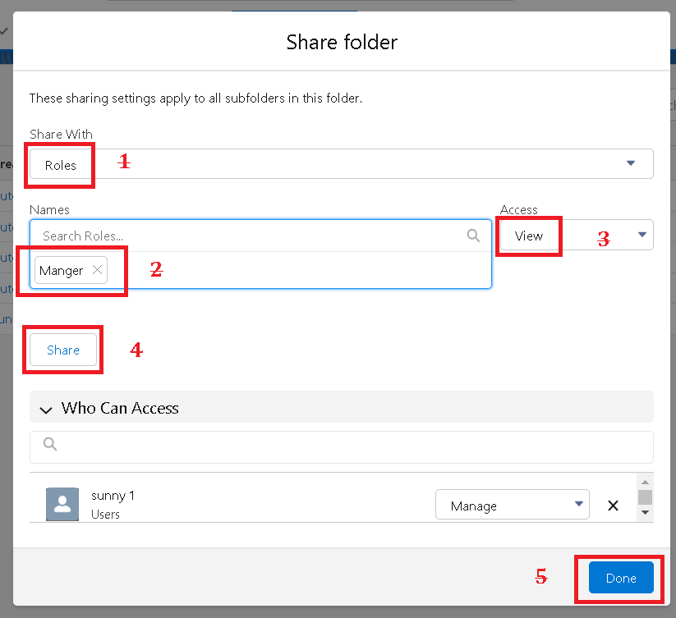

**Create reports type:**

1. Go to setup >> type users in quick find box >>select report type >> click on continue.
2. Click on new custom report type.
3. Select the primary object as “customer detail”
4. Give the report type label as “service information”
5. Report type name is autopopulated.
6. Keep the description as same.
7. Select store in category as “other reports”
8. Select the deployment status as “deployed”, click on next.
9. Now click on related object box

10.Click on select object, choose the appointment object as shown in figure.

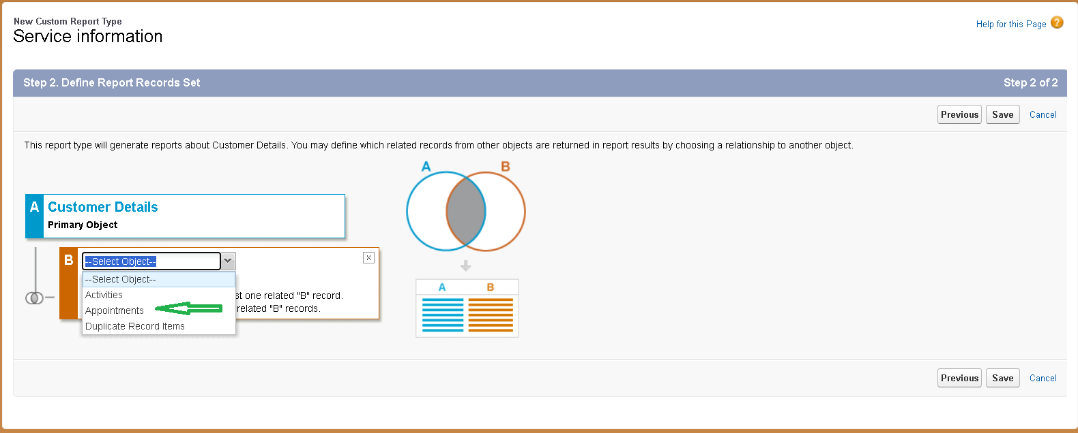

11.again click to relate another object.

12.and select the related object as “service records”.

13.repeat the process and select the related object as “billing details and feedback”.

14.and click on save.

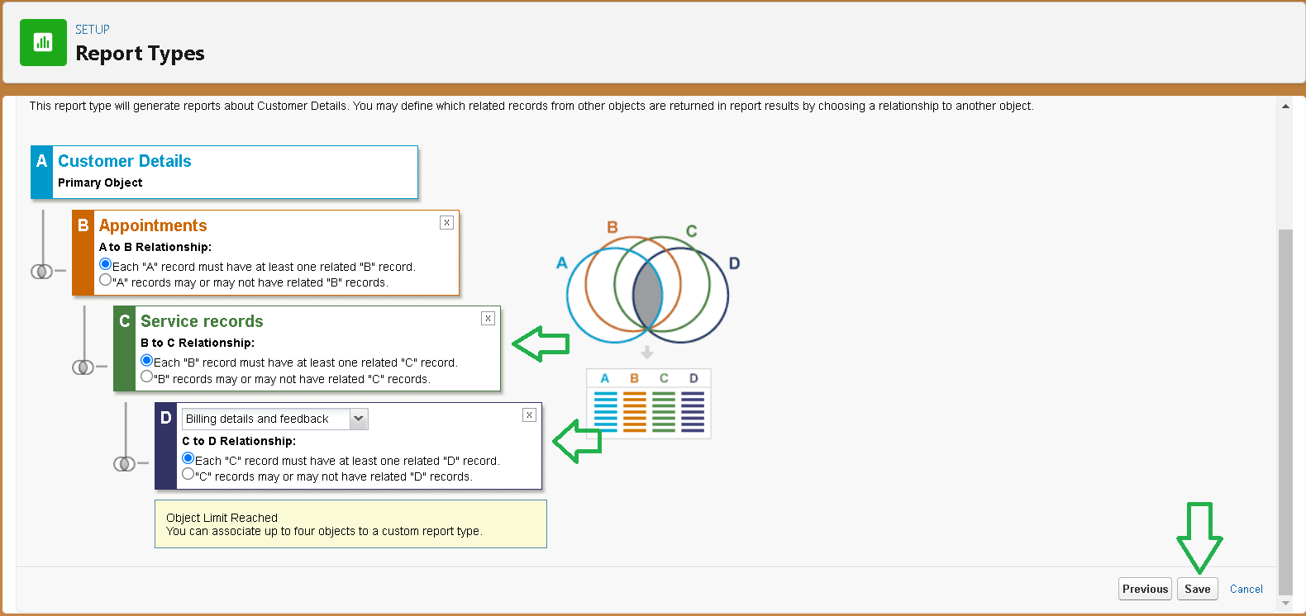

**Create report:**

**Note:** before creating reports, create latest “10” records in every object. Try to fill every field in each record for better experience.

1. Go to app >> click on the reports tab.
2. Click on new report.
3. Select the category as other reports, search for the service information, select that report, click on it. And click on start report.
4. Their outline pane is opened already, select the field that mentioned below in column section.
5. Customer name
6. Appointment date
7. Service status
8. Payment paid
9. Remove the unnecessary fields.
10. Select the fields that mentioned below in GROUPS ROWS section.
11. Rating for service
12. Select the field that mentioned below in GROUP ROWS section.
13. Payment status
14. Click on chart, select the line chart.
15. Click on save, give report name: New service information report

10.Report unique name is auto populated

11.Select the folder the created and click on save.

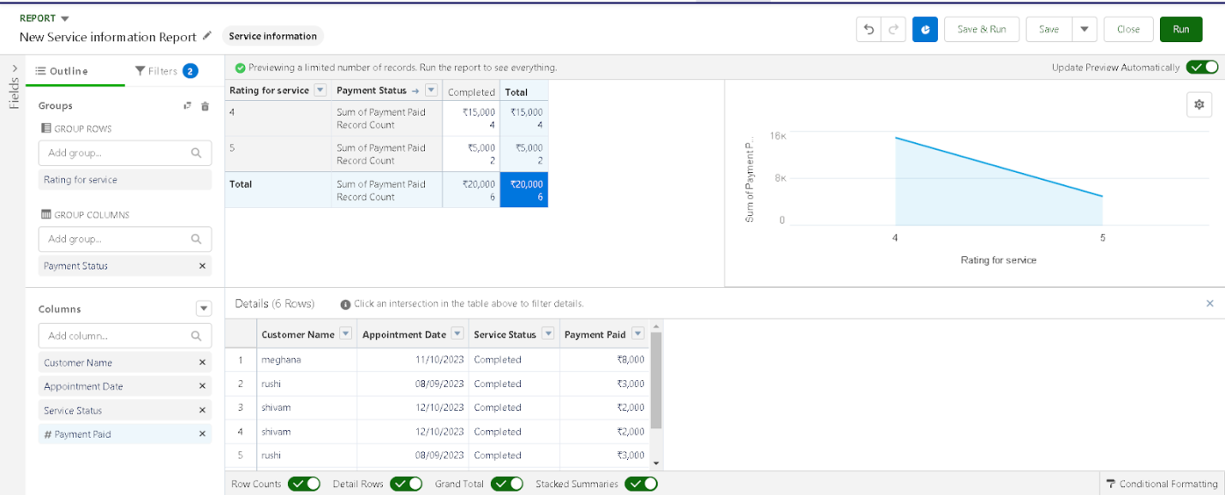

**Milestone – 16 Dashboards:**

**Create dashboards folder:**

1. Click on app launcher and search for dashboard.
2. Click on dashboard tab
3. Click new folder, give the folder label as “service rating dashboard”.
4. Folder unique name is auto populated
5. Click save
6. Follow the same steps form milestone 15, and activity 2 and provide the sharing setting for the folder that just created.

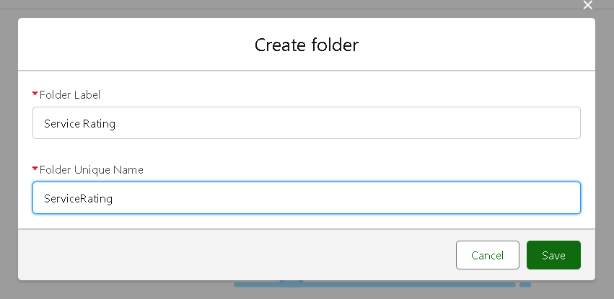

**Create dashboard:**

1. Go to the app launcher >> click on dashboard tabs.
2. Give the name as customer review select the folder that created “service rating” and click on create.
3. Select add component.
4. Select a report and click on select.
5. Select the line chart. Change the theme.
6. Click add and click on save and then click on done.
7. After that click on subscribe on top right
8. Set the frequency as “weekly”.
9. Set a day as Monday and click on save.

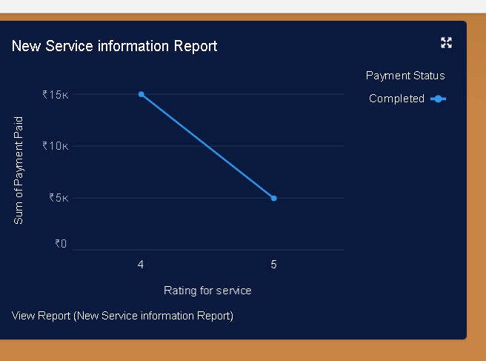

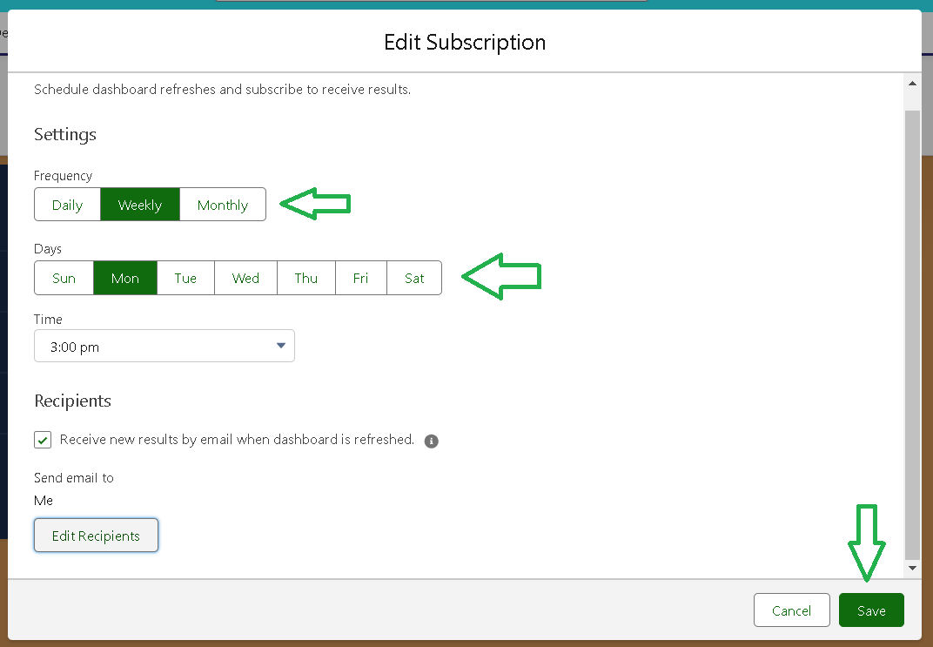

**THE END**